Lecture 8:

Spatial Localization and

Detection



Fei-Fei Li & Andrej Karpathy & Justin Johnson Lecture 8 1 1 Feb 2016

Administrative

* Project Proposals were due on Saturday
* Homework 2 due Friday 2/5
* Homework 1 grades out this week
* Midterm will be in-class on Wednesday 2/10



Fei-Fei Li & Andrej Karpathy & Justin Johnson Lecture 8 2 1 Feb 2016

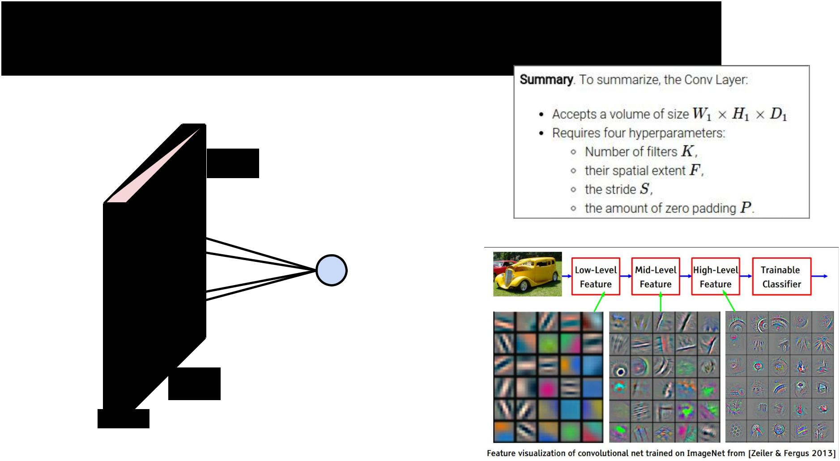**Convolution**

32

32

3



Fei-Fei Li & Andrej Karpathy & Justin Johnson Lecture 8 3 1 Feb 2016

**Pooling**

|  |  |  |  |
| --- | --- | --- | --- |
| 1 | 1 | 2 | 4 |
|  |  |  |  |
| 5 | **6** | 7 | **8** |
|  |  |  |  |
| **3** | 2 | 1 | 0 |
|  |  |  |  |
| 1 | 2 | 3 | **4** |
|  |  |  |  |

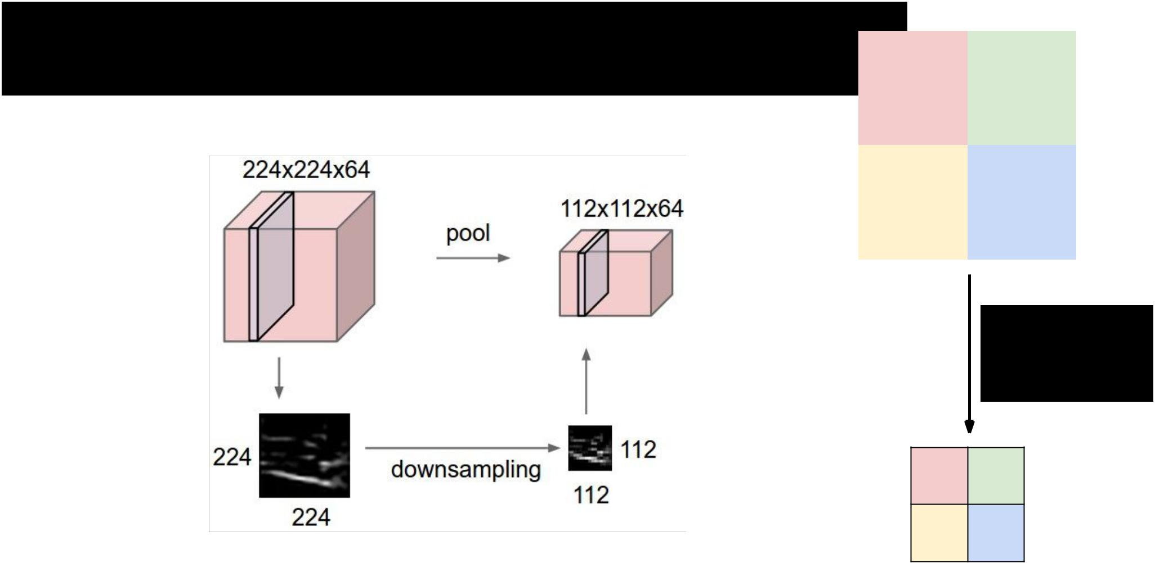

2x2 max

pooling

* 8

3 4



Fei-Fei Li & Andrej Karpathy & Justin Johnson Lecture 8 4 1 Feb 2016

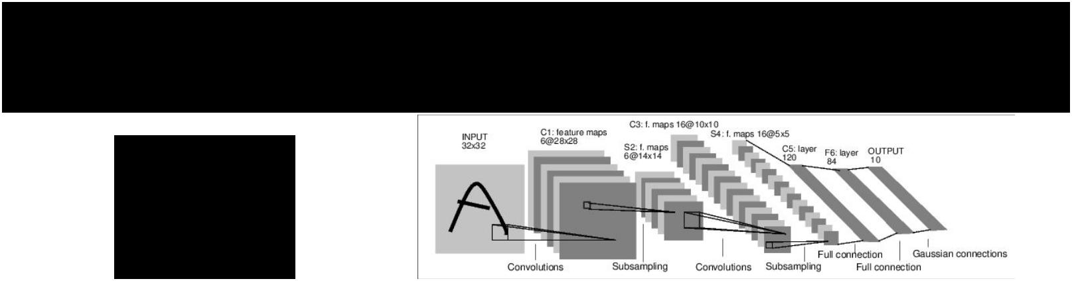**Case Studies**

LeNet

(1998)

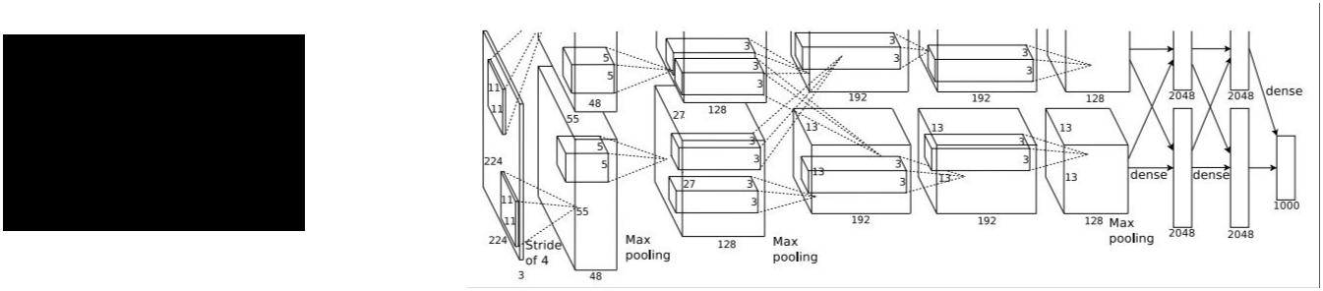

AlexNet

(2012)



ZFNet

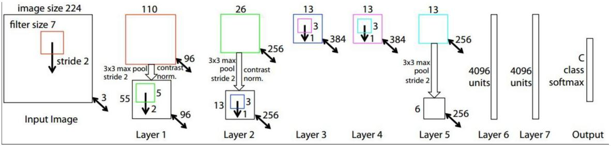

(2013)



Fei-Fei Li & Andrej Karpathy & Justin Johnson Lecture 8 5 1 Feb 2016

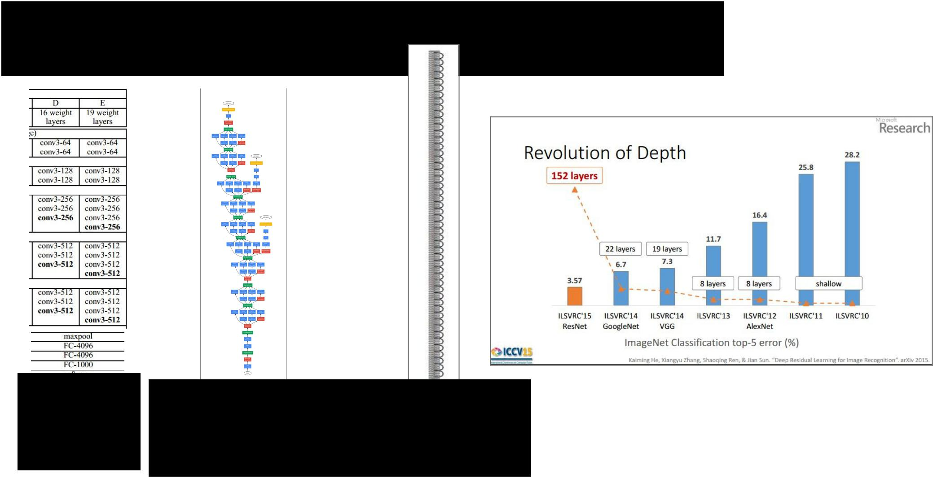

**Case Studies**

VGG GoogLeNet ResNet

(2014) (2014) (2015)



Fei-Fei Li & Andrej Karpathy & Justin Johnson Lecture 8 6 1 Feb 2016

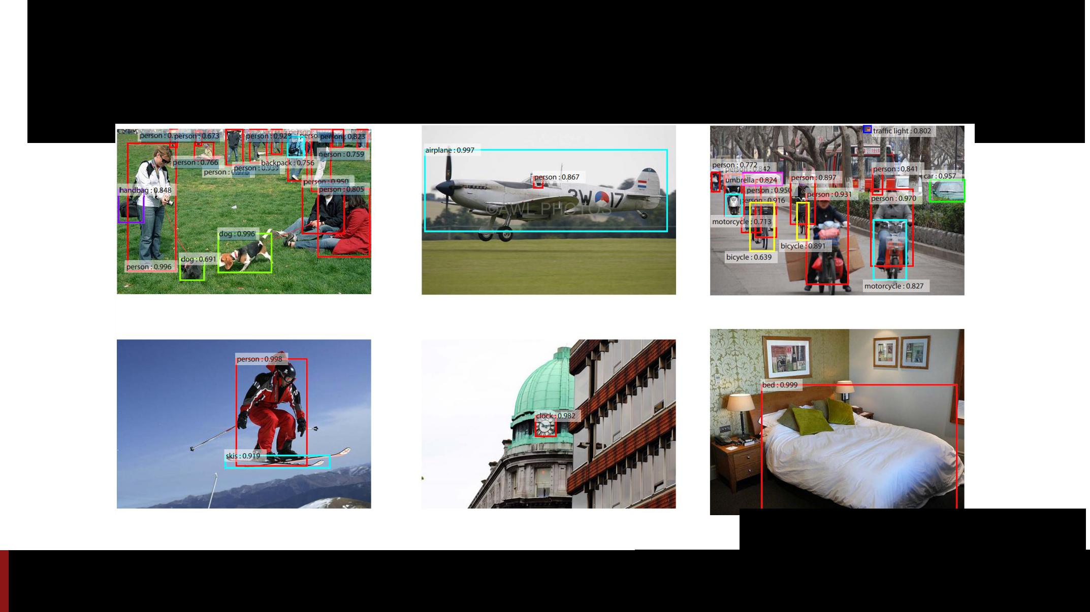Localization and Detection

Results from Faster R-CNN, Ren et al 2015

Fei-Fei Li & Andrej Karpathy & Justin Johnson Lecture 8 7 1 Feb 2016

Computer Vision Tasks

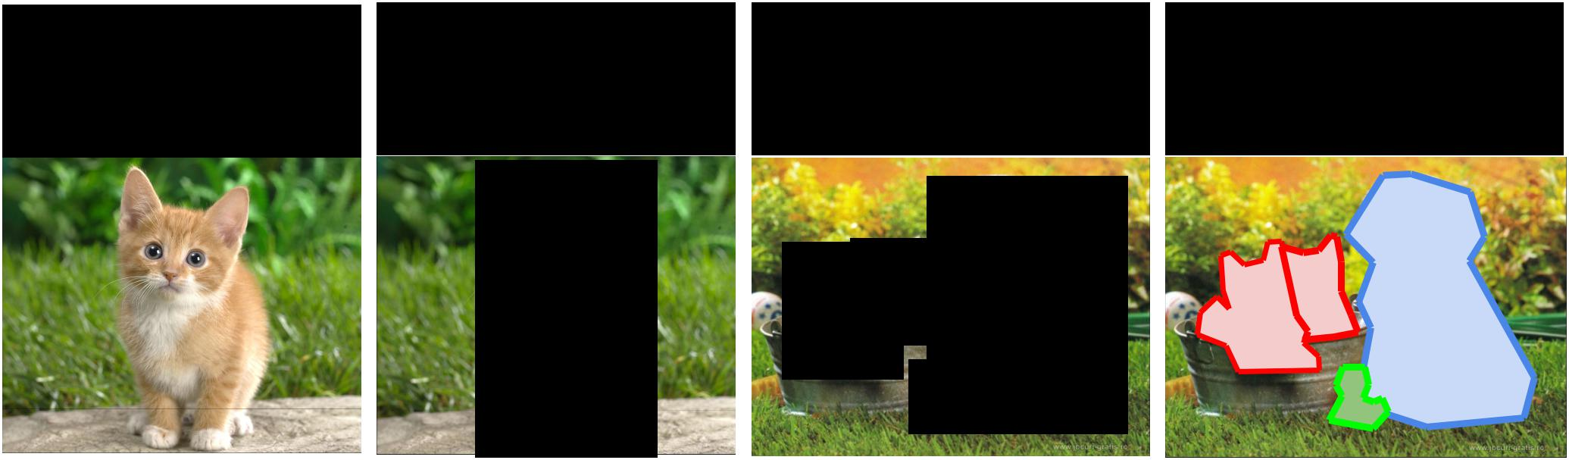

|  |  |  |  |  |  |  |  |  |  |  |  |  |  |  |
| --- | --- | --- | --- | --- | --- | --- | --- | --- | --- | --- | --- | --- | --- | --- |
| **Classification** | **Classification** | | | | | **Object Detection** | | | | | | | **Instance** |  |
| **+ Localization** | | | | | **Segmentation** |  |
|  |  |  |  |  |  |  |  |  |
|  |  |  |  |  |  |  |  |  |  |  |  |  |  |  |
|  |  |  |  |  |  |  |  |  |  |  |  |  |  |  |
|  |  |  |  |  |  |  |  |  |  |  |  |  |  |  |
|  |  |  |  |  |  |  |  |  |  |  |  |  |  |  |
|  |  |  |  |  |  |  |  |  |  |  |  |  |  |  |
|  |  |  |  |  |  |  |  |  |  |  |  |  |  |  |
|  |  |  |  |  |  |  |  |  |  |  |  |  |  |  |
|  |  |  |  |  |  |  |  |  |  |  |  |  |  |  |
|  |  |  |  |  |  |  |  |  |  |  |  |  |  |  |
|  |  |  |  |  |  |  |  |  |  |  |  |  |  |  |



CAT CAT CAT, DOG, DUCK CAT, DOG, DUCK



Single object Multiple objects

Fei-Fei Li & Andrej Karpathy & Justin Johnson Lecture 8 8 1 Feb 2016

Computer Vision Tasks

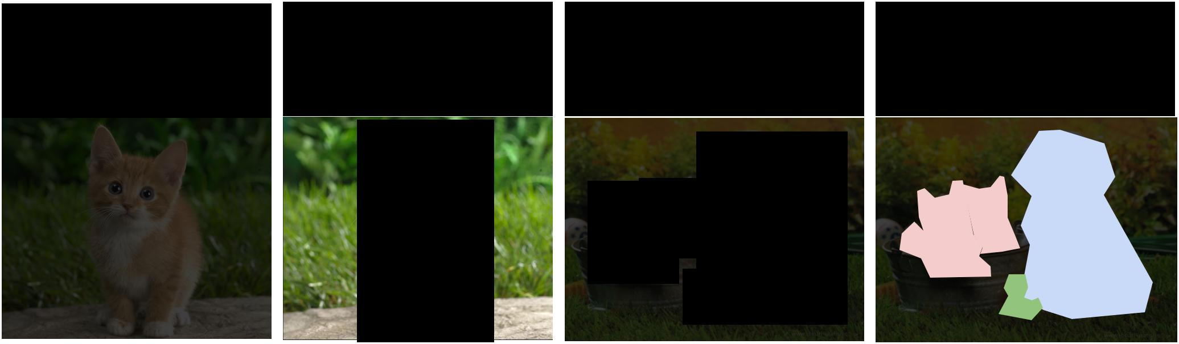

|  |  |  |  |  |  |  |  |  |  |  |  |  |  |  |
| --- | --- | --- | --- | --- | --- | --- | --- | --- | --- | --- | --- | --- | --- | --- |
| **Classification** | **Classification** | | | | | **Object Detection** | | | | | | | **Instance** |  |
| **+ Localization** | | | | | **Segmentation** |  |
|  |  |  |  |  |  |  |  |  |
|  |  |  |  |  |  |  |  |  |  |  |  |  |  |  |
|  |  |  |  |  |  |  |  |  |  |  |  |  |  |  |
|  |  |  |  |  |  |  |  |  |  |  |  |  |  |  |
|  |  |  |  |  |  |  |  |  |  |  |  |  |  |  |
|  |  |  |  |  |  |  |  |  |  |  |  |  |  |  |
|  |  |  |  |  |  |  |  |  |  |  |  |  |  |  |
|  |  |  |  |  |  |  |  |  |  |  |  |  |  |  |
|  |  |  |  |  |  |  |  |  |  |  |  |  |  |  |
|  |  |  |  |  |  |  |  |  |  |  |  |  |  |  |
|  |  |  |  |  |  |  |  |  |  |  |  |  |  |  |



Fei-Fei Li & Andrej Karpathy & Justin Johnson Lecture 8 9 1 Feb 2016



Classification + Localization: Task

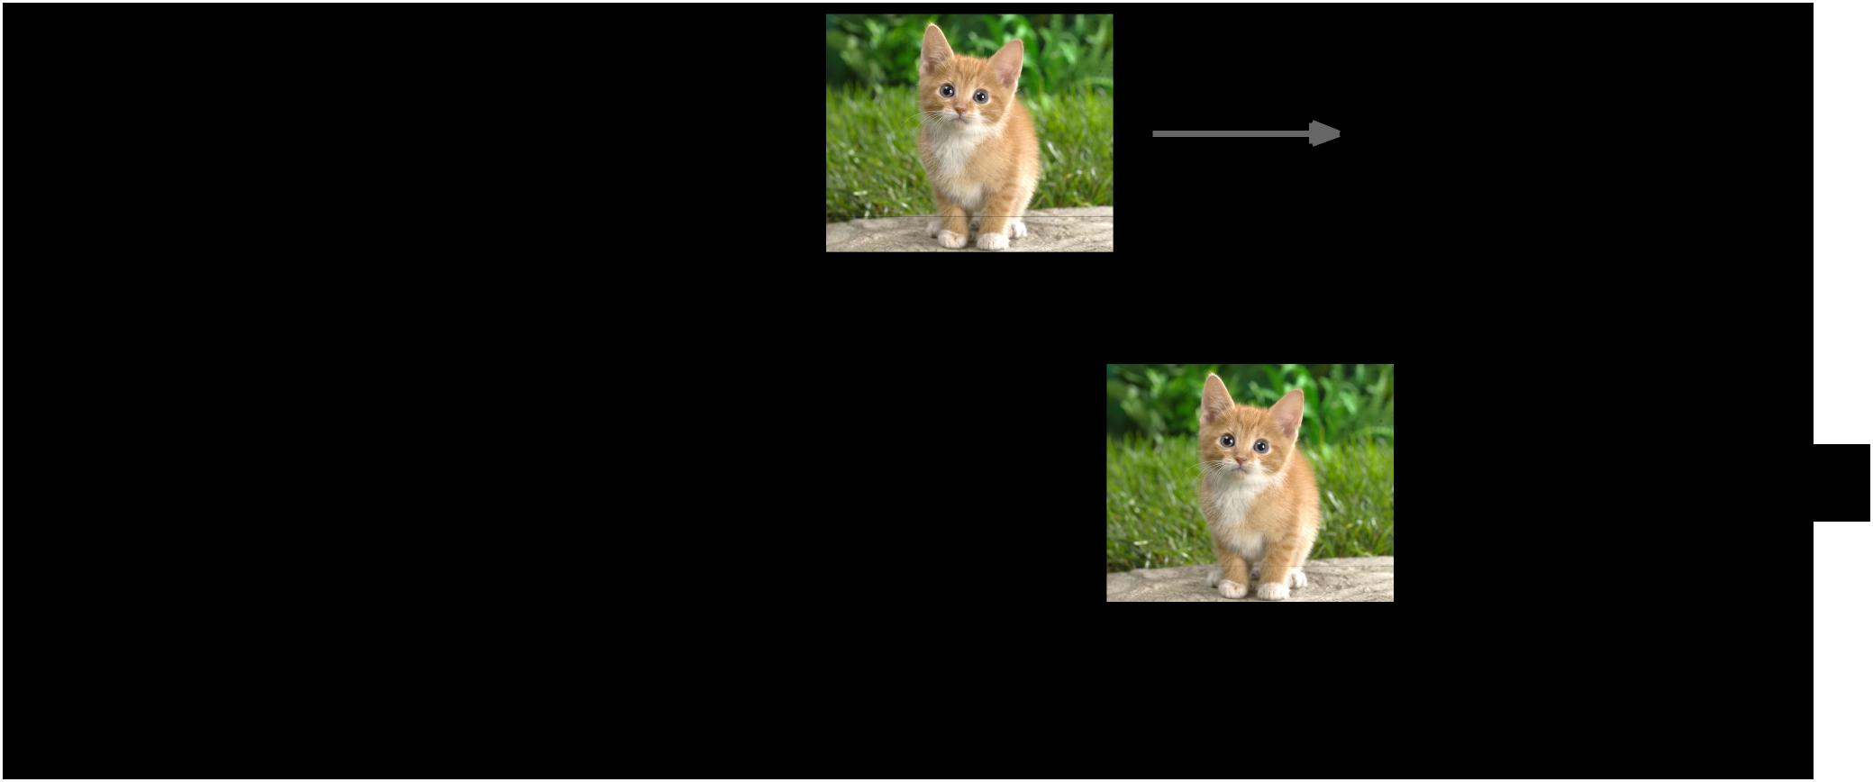

**Classification**: C classes

**Input:** Image

**Output:** Class label

**Evaluation metric:** Accuracy

**Localization**:

**Input:** Image

**Output**: Box in the image (x, y, w, h)

**Evaluation metric:** Intersection over Union

**Classification + Localization**: Do both



CAT



 (x, y, w, h)



|  |  |  |
| --- | --- | --- |
| Fei-Fei Li & Andrej Karpathy & Justin Johnson | Lecture 8 10 | 1 Feb 2016 |
|  |  |  |

Classification + Localization: ImageNet

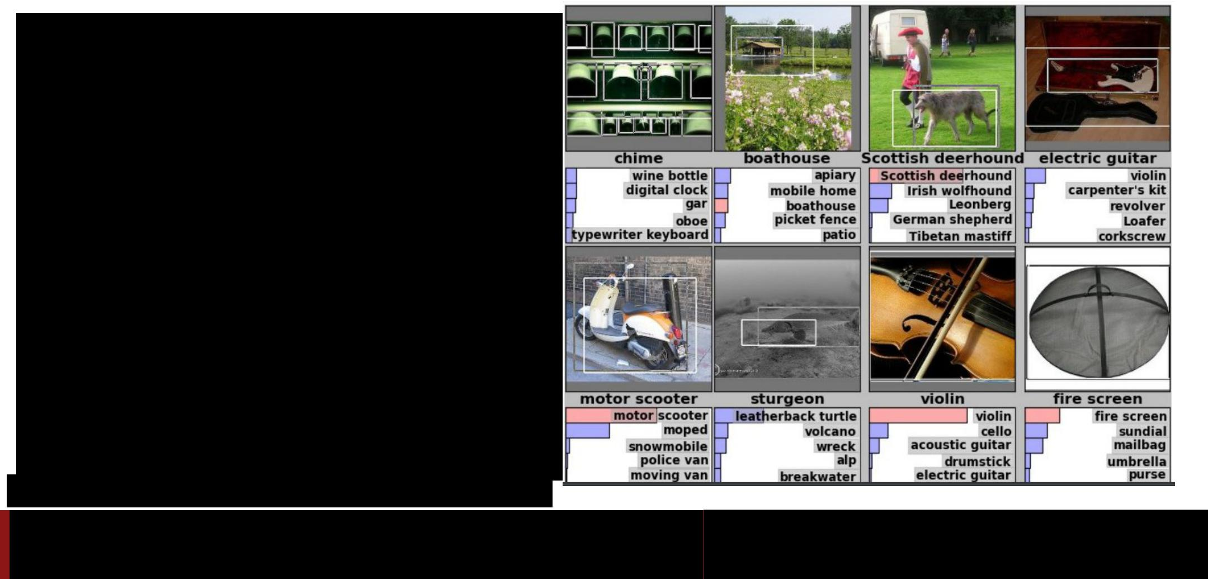

1000 classes (same as classification)

Each image has 1 class, at least one bounding box

~800 training images per class

Algorithm produces 5 (class, box) guesses

Example is correct if at least one one guess has correct class AND bounding box at least 0.5 intersection over union (IoU)

Krizhevsky et. al. 2012

Fei-Fei Li & Andrej Karpathy & Justin Johnson Lecture 8 11 1 Feb 2016



Idea #1: Localization as Regression



**Input**: image

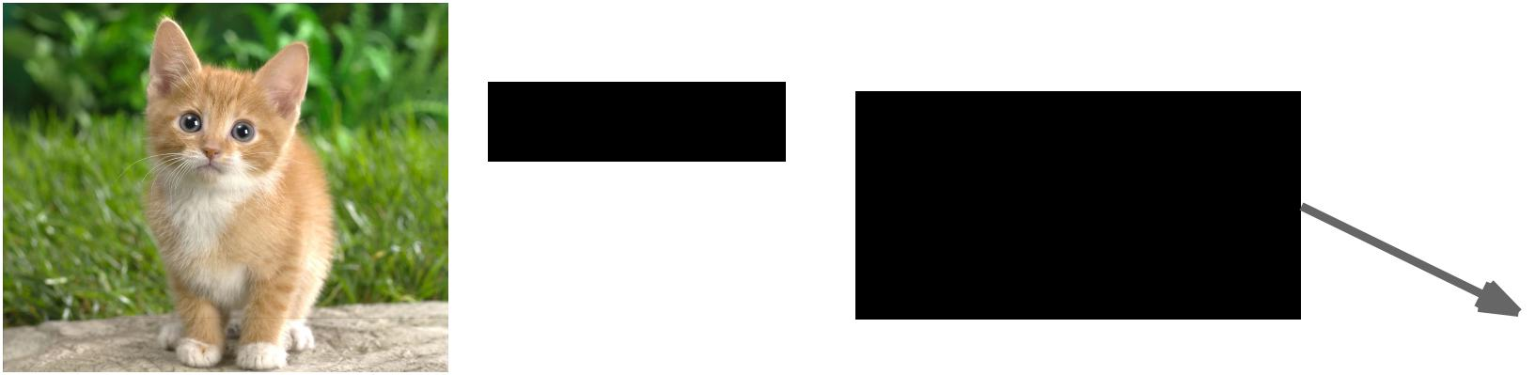

|  |  |  |  |
| --- | --- | --- | --- |
| Neural Net | | **Output**: |  |
|  |  | Box coordinates |  |
|  |  |  |
|  |  | (4 numbers) |  |



**Correct output**:

box coordinates



Only one object, (4 numbers)

simpler than detection



**Loss**:



L2 distance

|  |  |  |
| --- | --- | --- |
| Fei-Fei Li & Andrej Karpathy & Justin Johnson | Lecture 8 12 | 1 Feb 2016 |
|  |  |  |

Simple Recipe for Classification + Localization

**Step 1**: Train (or download) a classification model (AlexNet, VGG, GoogLeNet)

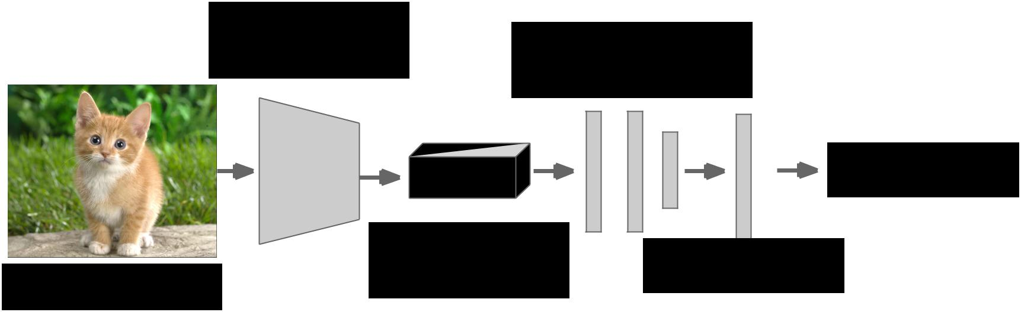

Convolution

and Pooling Fully-connected

layers

Softmax loss



|  |  |  |  |  |  |
| --- | --- | --- | --- | --- | --- |
|  | Final conv |  |  |  |  |
|  | Class scores | | |  |
| Image | feature map |  |
|  |  |  |  |
|  |  |  |  |  |



Fei-Fei Li & Andrej Karpathy & Justin Johnson Lecture 8 13 1 Feb 2016

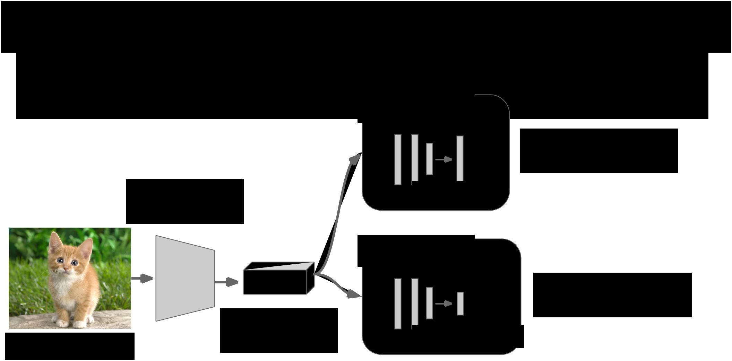Simple Recipe for Classification + Localization

**Step 2**: Attach new fully-connected “regression head” to the network

Convolution

and Pooling



|  |  |  |
| --- | --- | --- |
|  | Final conv |  |
| Image | feature map |  |
|  |  |

Fully-connected

layers

“Classification head”



Class scores

Fully-connected

layers

“Regression head”



Box coordinates



Fei-Fei Li & Andrej Karpathy & Justin Johnson Lecture 8 14 1 Feb 2016

Simple Recipe for Classification + Localization

**Step 3**: Train the regression head only with SGD and L2 loss

Fully-connected

layers



Convolution

and Pooling

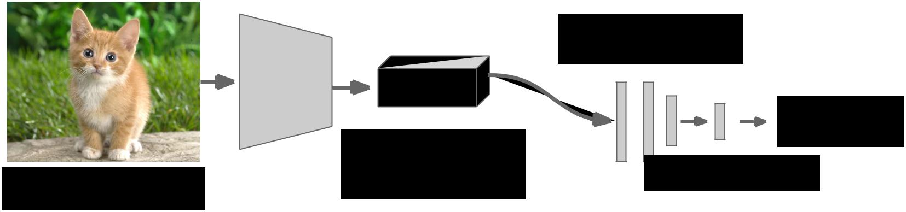

Class scores

Fully-connected

layers



L2 loss



Final conv

|  |  |  |  |
| --- | --- | --- | --- |
| Image | feature map | Box coordinates |  |
|  |  |  |



Fei-Fei Li & Andrej Karpathy & Justin Johnson Lecture 8 15 1 Feb 2016

Simple Recipe for Classification + Localization

**Step 4**: At test time use both heads

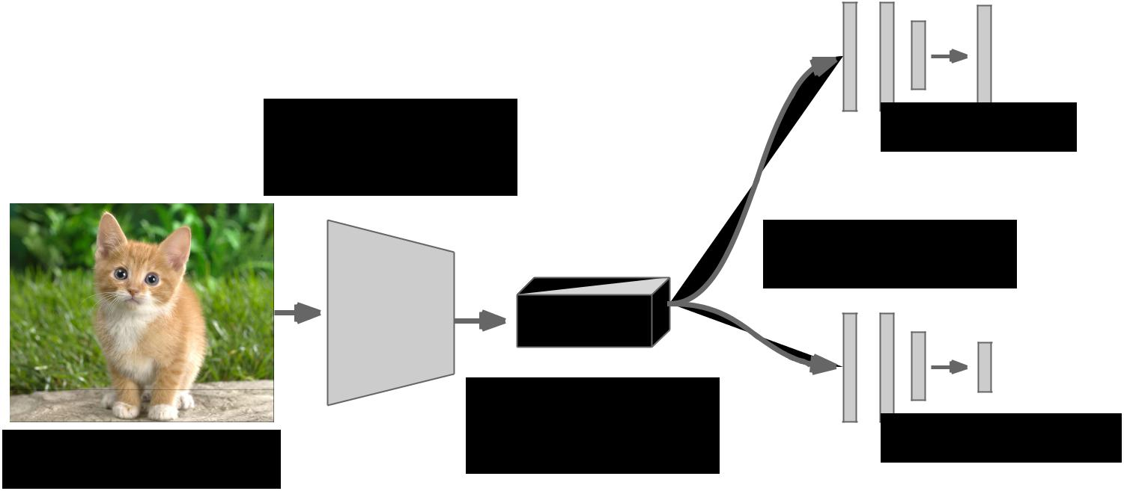

Convolution

and Pooling



|  |  |  |
| --- | --- | --- |
|  | Final conv |  |
| Image | feature map |  |
|  |  |

Fully-connected

layers



Class scores

Fully-connected

layers



Box coordinates



Fei-Fei Li & Andrej Karpathy & Justin Johnson Lecture 8 16 1 Feb 2016

Per-class vs class agnostic regression

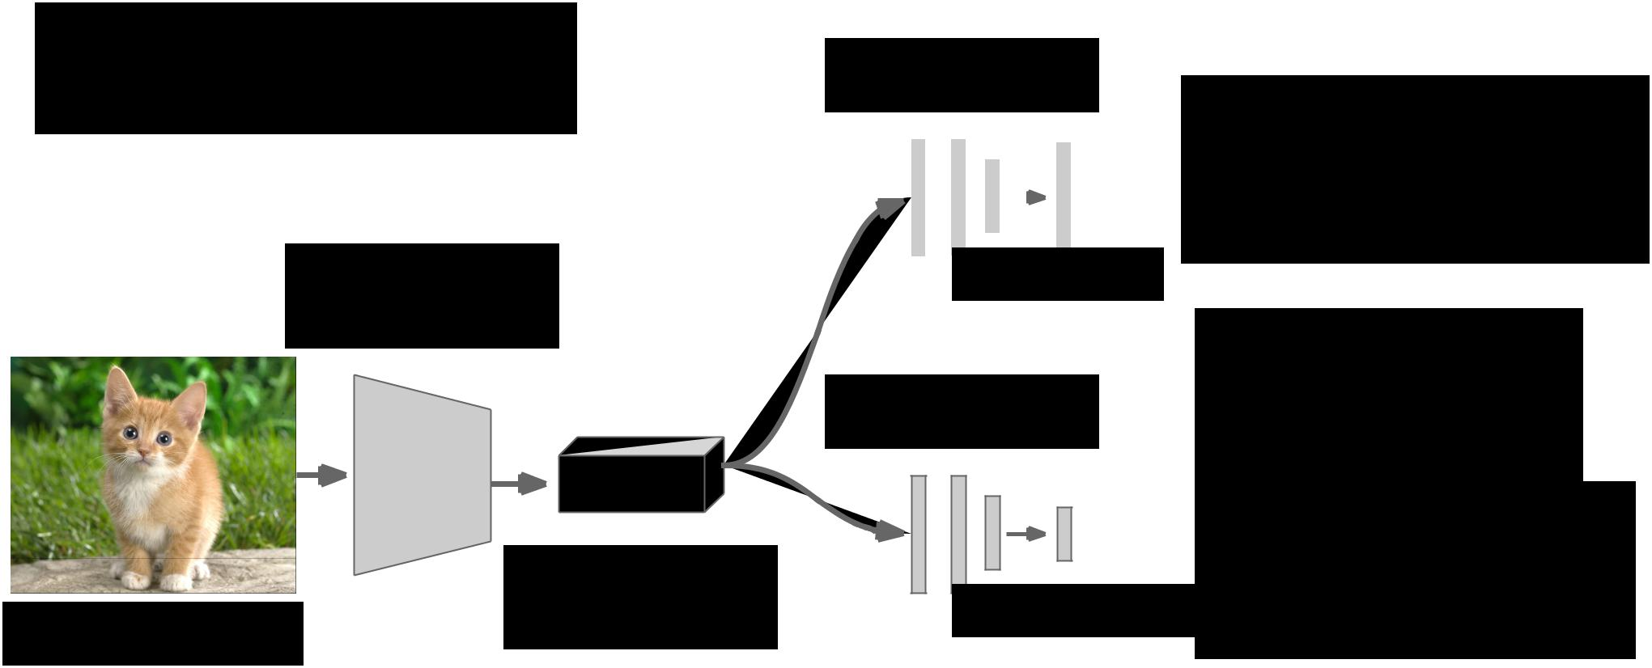

Assume classification

over C classes:

Convolution

and Pooling

|  |  |  |  |  |  |  |  |  |  |  |  |  |
| --- | --- | --- | --- | --- | --- | --- | --- | --- | --- | --- | --- | --- |
| Fully-connected | | | | | | | | | | |  |  |
|  | layers | | | | | | | | | | **Classification head**: |  |
|  |  |  |  |  |  |  |  |  |  |  |  |
|  |  |  |  |  |  |  |  |  |  |  | C numbers |  |
|  |  |  |  |  |  |  |  |  |  |  |  |
|  |  |  |  |  |  |  |  |  |  |  | (one per class) |  |
|  |  |  |  | Class | | | | |  | scores |  |
|  |  |  |  |  |  |  |
|  |  |  |  |  |  |  |



|  |  |  |
| --- | --- | --- |
|  | Final conv |  |
| Image | feature map |  |
|  |  |



Fully-connected

layers



Box coordinates



**Class agnostic:**

* numbers (one box)

**Class specific:** C x 4 numbers (one box per class)

Fei-Fei Li & Andrej Karpathy & Justin Johnson Lecture 8 17 1 Feb 2016

Where to attach the regression head?

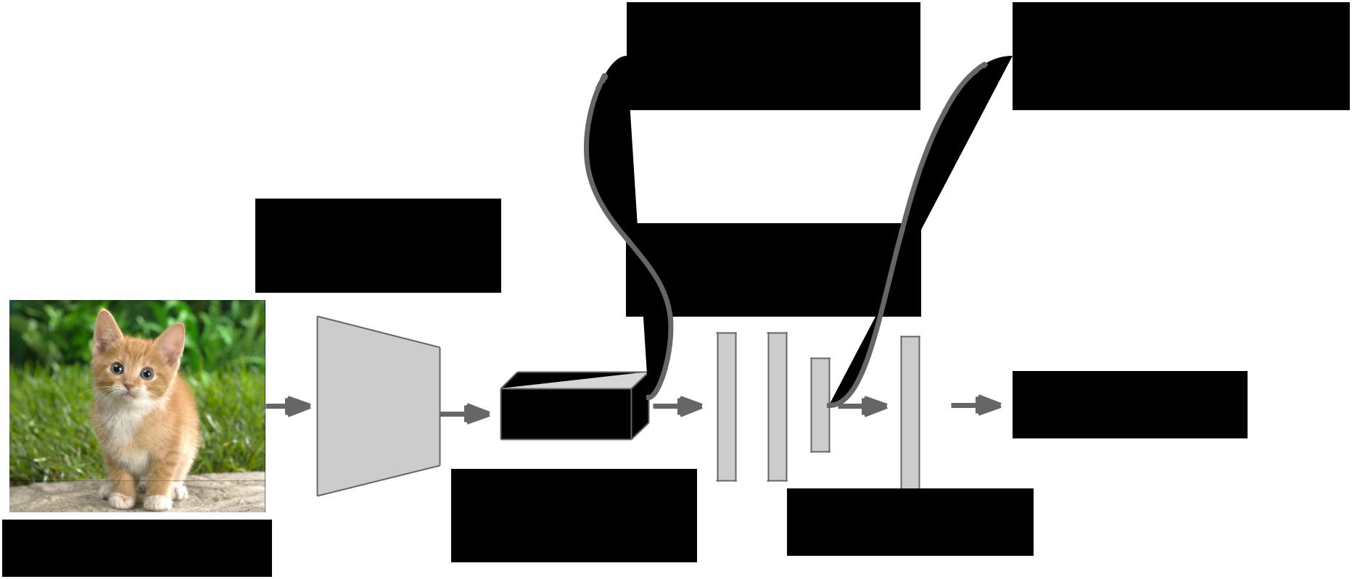

**After conv layers**: **After last FC layer**:

 Overfeat, VGG  DeepPose, R-CNN

Convolution

and Pooling Fully-connected

layers

Softmax loss



|  |  |  |  |  |  |
| --- | --- | --- | --- | --- | --- |
|  | Final conv |  |  |  |  |
|  | Class scores | | |  |
| Image | feature map |  |
|  |  |  |  |
|  |  |  |  |  |



Fei-Fei Li & Andrej Karpathy & Justin Johnson Lecture 8 18 1 Feb 2016

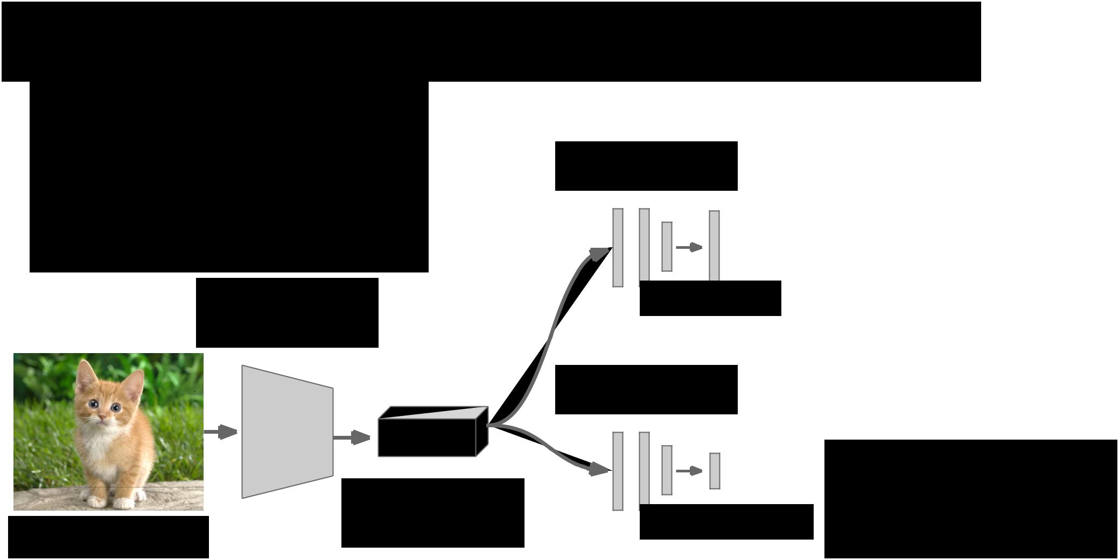Aside: Localizing multiple objects

Want to localize **exactly** K objects in each image

(e.g. whole cat, cat head, cat left ear, cat right ear for K=4)

Convolution

and Pooling



|  |  |  |
| --- | --- | --- |
|  | Final conv |  |
| Image | feature map |  |
|  |  |

Fully-connected

layers



Class scores

Fully-connected

layers

K x 4 numbers



(one box per object)

Box coordinates



Fei-Fei Li & Andrej Karpathy & Justin Johnson Lecture 8 19 1 Feb 2016

Aside: Human Pose Estimation

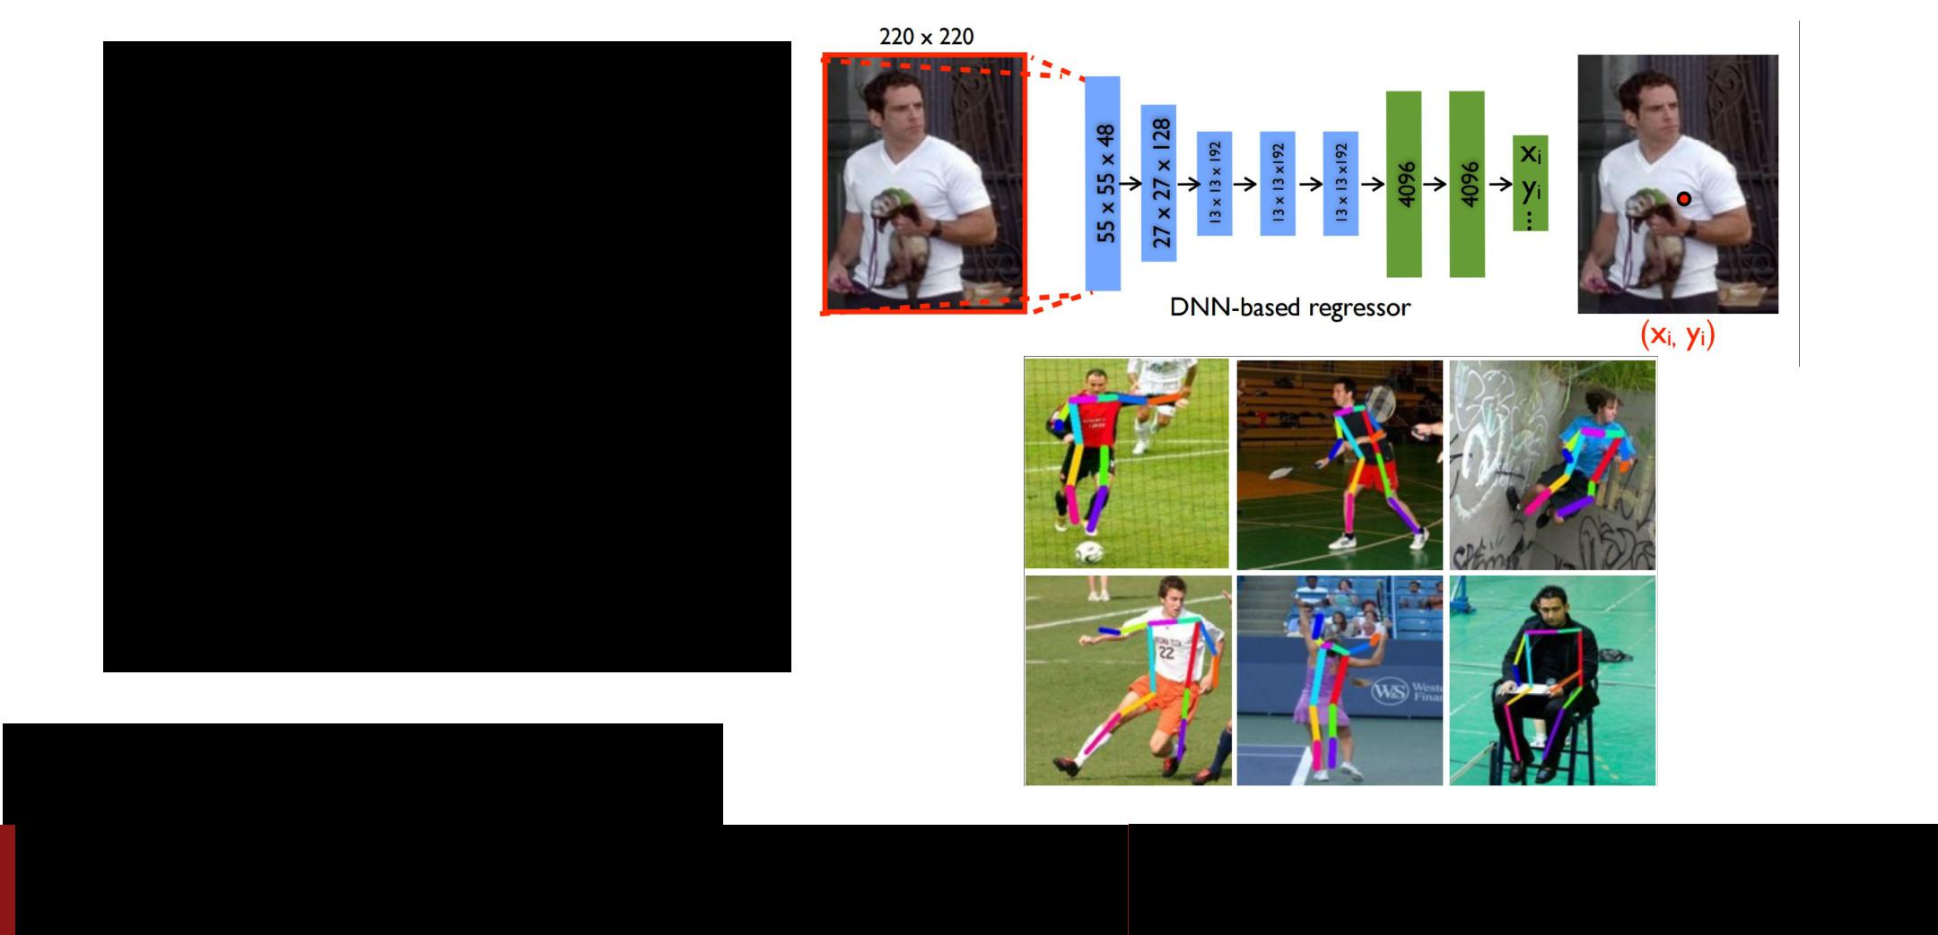

Represent a person by K joints

Regress (x, y) for each joint from last fully-connected layer of AlexNet

(Details: Normalized coordinates, iterative refinement)

Toshev and Szegedy, “DeepPose: Human Pose Estimation via Deep Neural Networks”, CVPR 2014

Fei-Fei Li & Andrej Karpathy & Justin Johnson Lecture 8 20 1 Feb 2016

Localization as Regression



Very simple

Think if you can use this for projects



Fei-Fei Li & Andrej Karpathy & Justin Johnson Lecture 8 21 1 Feb 2016

Idea #2: Sliding Window



* Run classification + regression network at multiple locations on a high-resolution image
* Convert fully-connected layers into convolutional layers for efficient computation
* Combine classifier and

regressor predictions across all scales for final prediction



Fei-Fei Li & Andrej Karpathy & Justin Johnson Lecture 8 22 1 Feb 2016

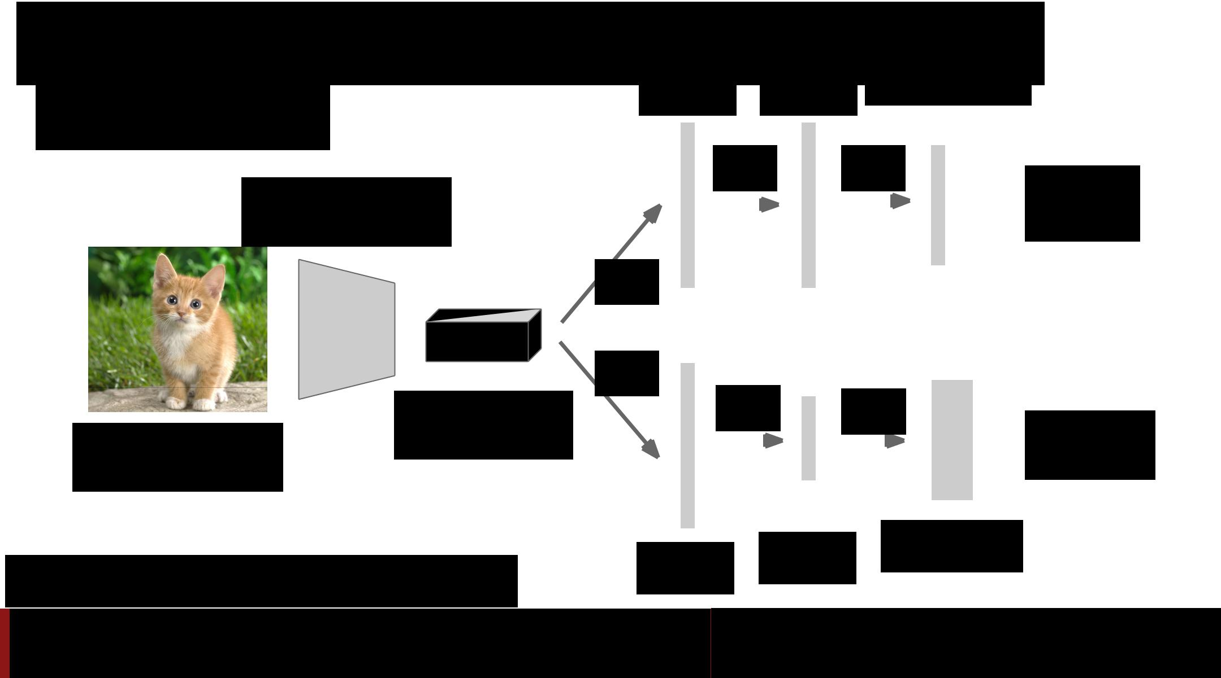Sliding Window: Overfeat

|  |  |  |  |  |  |  |  |  |  |  |  |  |
| --- | --- | --- | --- | --- | --- | --- | --- | --- | --- | --- | --- | --- |
| Winner of ILSVRC 2013 | 4096 | | | | 4096 | | | Class scores: | | | |  |
| 1000 | | | |  |
|  |  |  |  |  |  |  |  |
| localization challenge |  |  |  |  |  |  |  |  |  |  |  |  |
|  |  |  |  | FC |  |  |  | FC | |  | Softmax |  |
| Convolution |  |  |  |  |  |  |  |  |  |  |  |
|  |  |  |  |  |  |  |  |  |  | loss |  |
| + pooling |  |  |  |  |  |  |  |  |  |  |  |
|  |  |  |  |  |  |  |  |  |  |  |  |
|  | FC |  |  |  |  |  |  |  |  |  |  |  |
|  |  |  |  |  |  |  |  |  |  |  |  |
|  |  |  |  |  |  |  |  |  |  |  |  |



|  |  |  |  |  |  |  |  |  |  |  |  |  |  |
| --- | --- | --- | --- | --- | --- | --- | --- | --- | --- | --- | --- | --- | --- |
|  | Feature map: | FC |  |  | FC |  |  |  | FC | |  | Euclidean |  |
|  |  |  |  |  |  |  |  |
|  |  |  |  |  |  |  |  |  |
| Image: | 1024 x 5 x 5 |  |  |  |  |  |  |  |  |  |  |  |
|  |  |  |  |  |  |  |  |  |
|  |  |  |  |  |  |  |  |  |  | loss |  |
| 3 x 221 x 221 |  |  |  |  |  |  |  |  |  |  |  |  |
|  |  |  |  |  |  |  |  |  |  |  |  |  |
|  |  |  |  |  |  |  |  |  |  |  |  |  |  |
|  |  |  |  |  |  | 1024 | | |  | Boxes: | | |  |
| Sermanet et al, “Integrated Recognition, Localization and | | 4096 | | |  |  |  |
|  |  | 1000 x 4 | | |  |
|  |  |  |  |  |  |



Detection using Convolutional Networks”, ICLR 2014

Fei-Fei Li & Andrej Karpathy & Justin Johnson Lecture 8 23 1 Feb 2016

Sliding Window: Overfeat

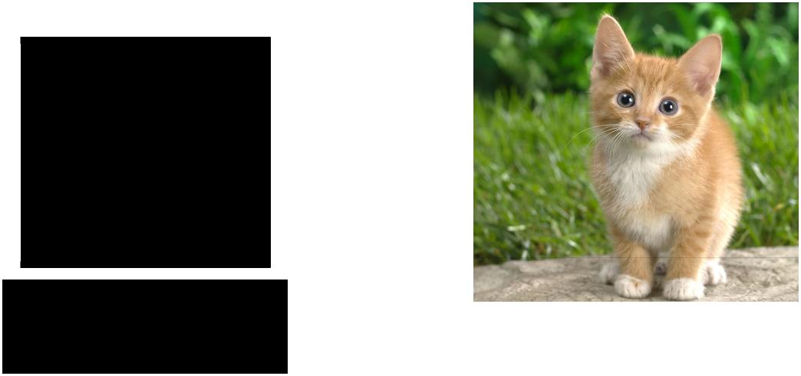

Network input:



3 x 221 x 221 Larger image:

3 x 257 x 257



Fei-Fei Li & Andrej Karpathy & Justin Johnson Lecture 8 24 1 Feb 2016

Sliding Window: Overfeat



0.5



|  |  |  |  |
| --- | --- | --- | --- |
| Network input: | Larger image: | Classification scores: |  |
| 3 x 221 x 221 |  |
|  | 3 x 257 x 257 | P(cat) |  |



Fei-Fei Li & Andrej Karpathy & Justin Johnson Lecture 8 25 1 Feb 2016

Sliding Window: Overfeat



0.5 0.75



|  |  |  |  |
| --- | --- | --- | --- |
| Network input: | Larger image: | Classification scores: |  |
| 3 x 221 x 221 |  |
|  | 3 x 257 x 257 | P(cat) |  |



Fei-Fei Li & Andrej Karpathy & Justin Johnson Lecture 8 26 1 Feb 2016

Sliding Window: Overfeat



|  |  |  |  |  |  |  |  |  |  |
| --- | --- | --- | --- | --- | --- | --- | --- | --- | --- |
|  |  |  |  |  |  | 0.5 | 0.75 |  |  |
|  |  |  |  |  |  |  |  |
|  |  |  |  |  |  |  |  |
|  |  |  |  |  |  |  |  |  |  |
|  |  |  |  |  |  | 0.6 |  |  |  |
|  |  |  |  |  |  |  |  |  |  |
| Network input: |  |  |  |  | Classification scores: | | | |  |
|  |  |  |  |  |
|  | Larger image: | | |  |
| 3 x 221 x 221 |  |  |
|  |  | 3 x 257 x 257 | | |  | P(cat) | | |  |



Fei-Fei Li & Andrej Karpathy & Justin Johnson Lecture 8 27 1 Feb 2016

Sliding Window: Overfeat



|  |  |  |  |  |  |  |  |  |
| --- | --- | --- | --- | --- | --- | --- | --- | --- |
|  |  |  |  |  | 0.5 | 0.75 |  |  |
|  |  |  |  |  |  |  |
|  |  |  |  |  |  |  |
|  |  |  |  |  |  |  |
|  |  |  |  |  |  |  |  |  |
|  |  |  |  |  | 0.6 | 0.8 |  |  |
|  |  |  |  |  |  |  |  |  |
| Network input: |  |  |  | Classification scores: | | | |  |
| Larger image: | |  |  |
| 3 x 221 x 221 |  |  |
|  | 3 x 257 x 257 | |  |  | P(cat) | | |  |



Fei-Fei Li & Andrej Karpathy & Justin Johnson Lecture 8 28 1 Feb 2016

Sliding Window: Overfeat



|  |  |  |  |  |  |  |  |  |  |  |
| --- | --- | --- | --- | --- | --- | --- | --- | --- | --- | --- |
|  |  |  |  |  |  |  |  |  |  |  |
|  |  |  |  |  |  |  |  |  |  |  |
|  |  |  |  |  |  |  | 0.5 | 0.75 |  |  |
|  |  |  |  |  |  |  |  |  |  |  |
|  |  |  |  |  |  |  | 0.6 | 0.8 |  |  |
|  |  |  |  |  |  |  |  |  |  |  |
| Network input: |  |  |  |  |  | Classification scores: | | | |  |
|  |  |  |  |  |  |
|  |  |  |  |  |  |
| Larger image: | | |  |  |  |
| 3 x 221 x 221 |  |  |  |
|  | 3 x 257 x 257 | | |  |  |  | P(cat) | | |  |



Fei-Fei Li & Andrej Karpathy & Justin Johnson Lecture 8 29 1 Feb 2016

Sliding Window: Overfeat



Greedily merge boxes and

scores (details in paper)



0.8



|  |  |  |  |  |
| --- | --- | --- | --- | --- |
| Network input: |  |  | Classification score: P |  |
| Larger image: | |  |
| 3 x 221 x 221 |  |
|  | 3 x 257 x 257 | | (cat) |  |



Fei-Fei Li & Andrej Karpathy & Justin Johnson Lecture 8 30 1 Feb 2016

Sliding Window: Overfeat



In practice use many sliding window locations and multiple scales

Window positions + score maps Box regression outputs Final Predictions

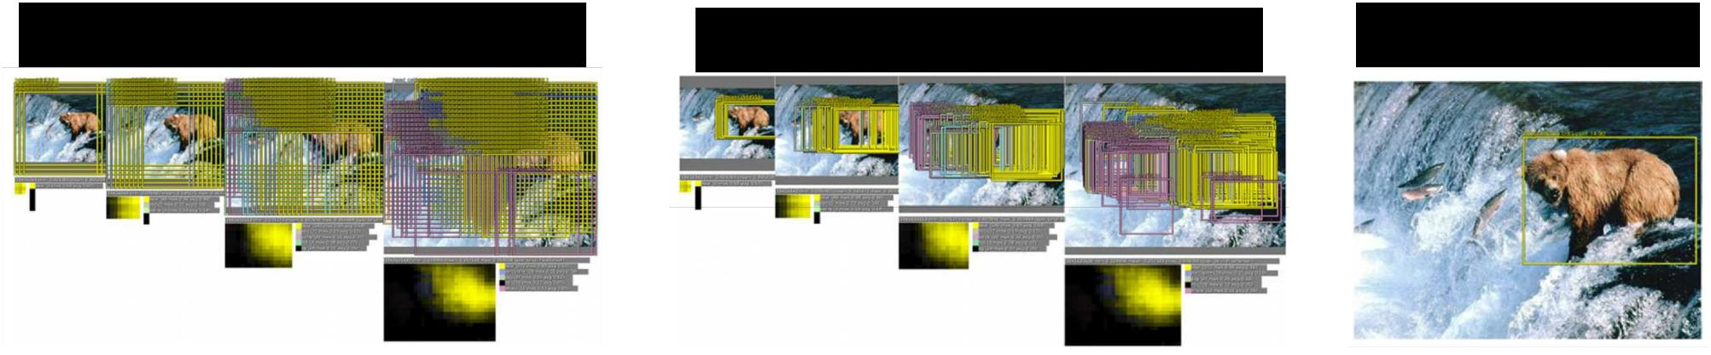

Sermanet et al, “Integrated Recognition, Localization and Detection using Convolutional Networks”, ICLR 2014

Fei-Fei Li & Andrej Karpathy & Justin Johnson Lecture 8 31 1 Feb 2016

Efficient Sliding Window: Overfeat

Image:

3 x 221 x 221

|  |  |  |  |  |  |  |  |  |  |
| --- | --- | --- | --- | --- | --- | --- | --- | --- | --- |
| 4096 | | | 4096 | | | Class scores: | | |  |
| 1000 | | |  |
|  |  |  |  |  |  |  |
|  |  |  |  |  |  |  |  |  |  |
|  |  | FC |  |  |  | FC | | |  |

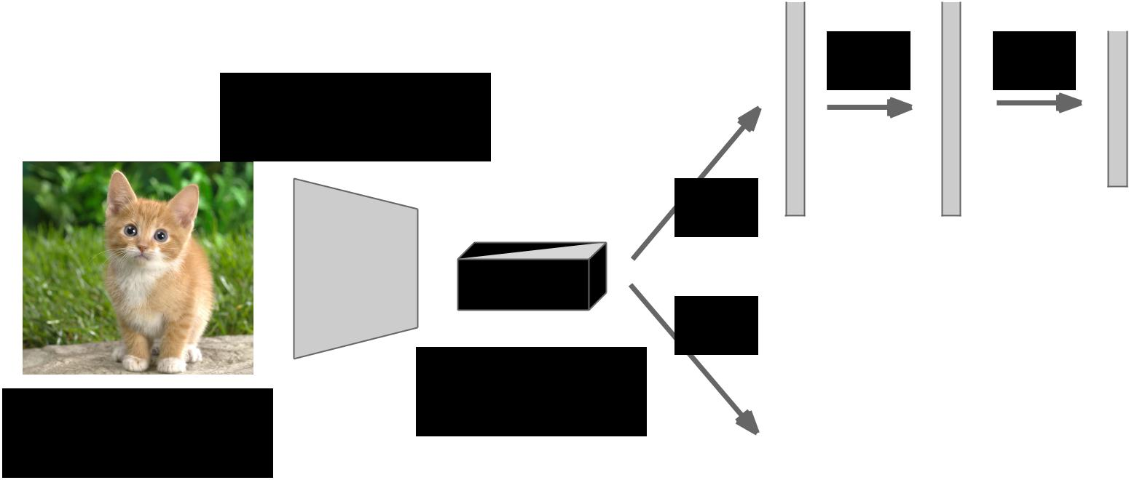

Convolution



+ pooling

FC



|  |  |  |  |  |  |  |  |  |  |  |
| --- | --- | --- | --- | --- | --- | --- | --- | --- | --- | --- |
|  | FC |  |  |  |  |  |  |  |  |  |
| Feature map: |  |  |  | FC | |  |  | FC | |  |
| 1024 x 5 x 5 |  |  |  |  |  |  |  |  |  |  |
|  |  |  |  |  |  |  |  |  |  |
|  |  |  |  |  |  |  |  |  |  |  |
|  |  |  |  |  |  |  |  |  |  |  |

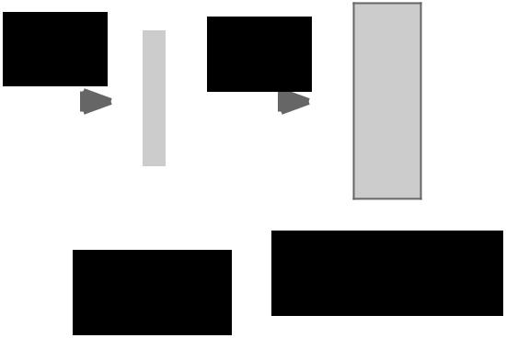

|  |  |  |  |
| --- | --- | --- | --- |
| 4096 | 1024 | Boxes: |  |
| 1000 x 4 |  |
|  |  |



Fei-Fei Li & Andrej Karpathy & Justin Johnson Lecture 8 32 1 Feb 2016

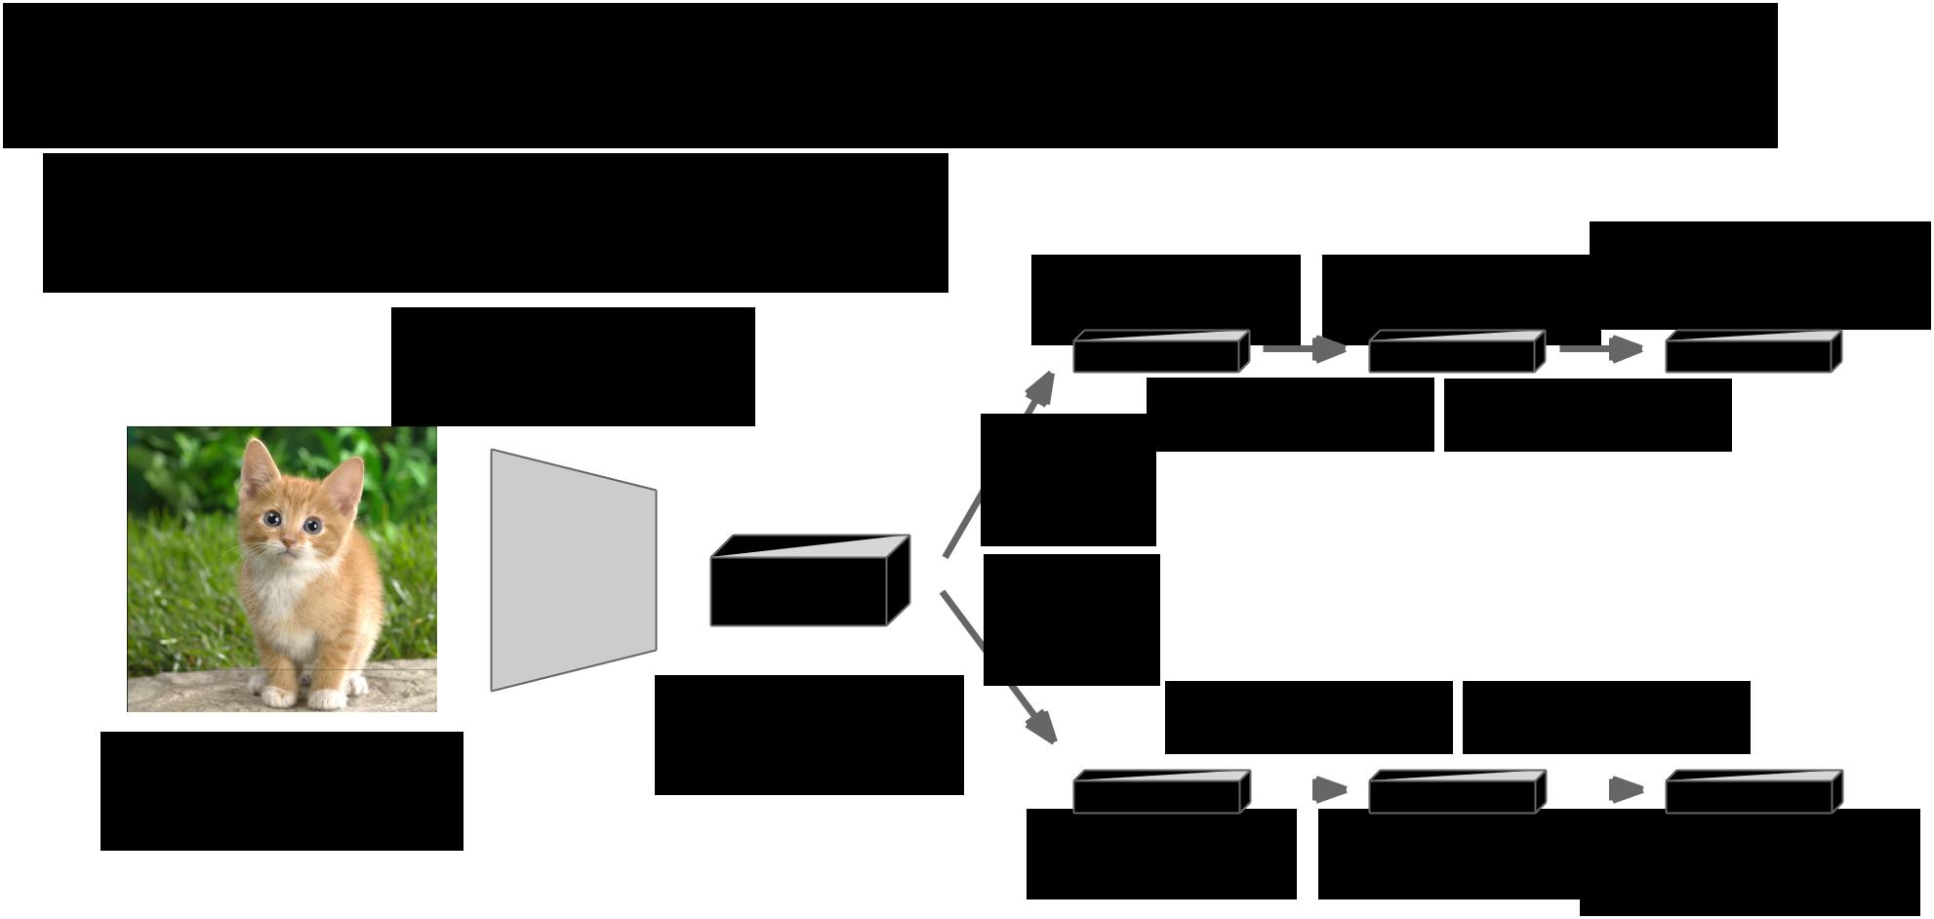Efficient Sliding Window: Overfeat

Efficient sliding window by converting fully-connected layers into convolutions

|  |  |  |  |
| --- | --- | --- | --- |
| 4096 x 1 x 1 | 1024 x 1 x 1 | Class scores: |  |
| 1000 x 1 x 1 |  |

Convolution

+ pooling

Feature map:

Image: 1024 x 5 x 5 3 x 221 x 221

|  |  |  |  |  |  |
| --- | --- | --- | --- | --- | --- |
| 1 x 1 conv | | | 1 x 1 conv | | |
| 5 x 5 |  |  |  |  |  |
| conv |  |  |  |  |  |
| 5 x 5 |  |  |  |  |  |
| conv |  |  |  |  |  |
| 1 x 1 conv | | | 1 x 1 conv | | |
|  |  |  | |  |  |
| 4096 x 1 x 1 |  | 1024 x 1 x 1 Box coordinates: | | | |
|  |  |  |  |  | (4 x 1000) x 1 x 1 |



Fei-Fei Li & Andrej Karpathy & Justin Johnson Lecture 8 33 1 Feb 2016

Efficient Sliding Window: Overfeat

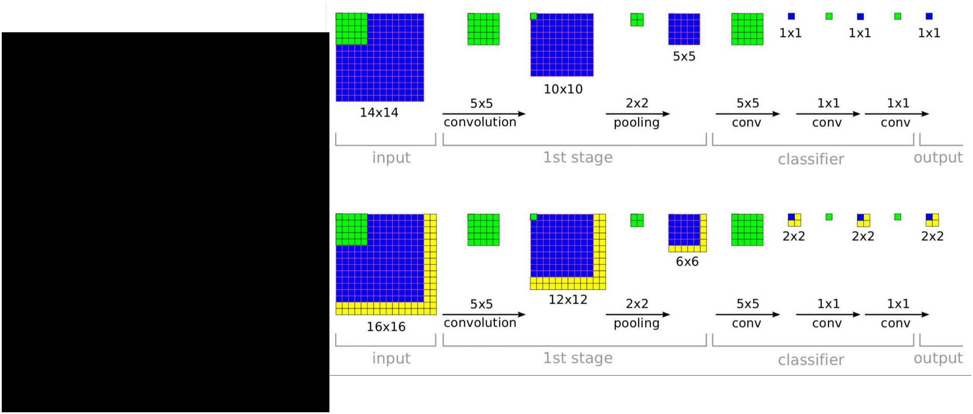

**Training time:** Small image, 1x 1 classifier output

**Test time:** Larger image, 2 x 2classifier output, only extra compute at yellow regions



Sermanet et al, “Integrated Recognition, Localization and Detection using Convolutional Networks”, ICLR 2014

Fei-Fei Li & Andrej Karpathy & Justin Johnson Lecture 8 34 1 Feb 2016

ImageNet Classification + Localization

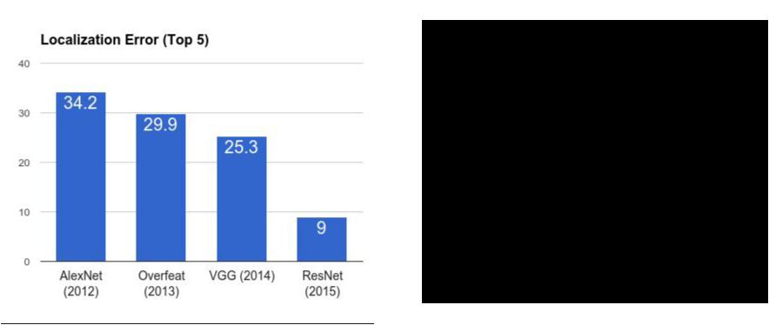

**AlexNet**: Localization method not published

**Overfeat**: Multiscale convolutional regression

with box merging

**VGG**: Same as Overfeat, but fewer scales

and locations; simpler method, gains all due

to deeper features

**ResNet:** Different localization method (RPN)

and much deeper features



Fei-Fei Li & Andrej Karpathy & Justin Johnson Lecture 8 35 1 Feb 2016

Computer Vision Tasks



|  |  |  |  |  |  |  |  |  |  |  |  |  |  |  |
| --- | --- | --- | --- | --- | --- | --- | --- | --- | --- | --- | --- | --- | --- | --- |
| **Classification** | **Classification** | | | | | **Object Detection** | | | | | | | **Instance** |  |
| **+ Localization** | | | | | **Segmentation** |  |
|  |  |  |  |  |  |  |  |  |
|  |  |  |  |  |  |  |  |  |  |  |  |  |  |  |
|  |  |  |  |  |  |  |  |  |  |  |  |  |  |  |
|  |  |  |  |  |  |  |  |  |  |  |  |  |  |  |
|  |  |  |  |  |  |  |  |  |  |  |  |  |  |  |
|  |  |  |  |  |  |  |  |  |  |  |  |  |  |  |
|  |  |  |  |  |  |  |  |  |  |  |  |  |  |  |
|  |  |  |  |  |  |  |  |  |  |  |  |  |  |  |
|  |  |  |  |  |  |  |  |  |  |  |  |  |  |  |
|  |  |  |  |  |  |  |  |  |  |  |  |  |  |  |
|  |  |  |  |  |  |  |  |  |  |  |  |  |  |  |



Fei-Fei Li & Andrej Karpathy & Justin Johnson Lecture 8 36 1 Feb 2016

Computer Vision Tasks

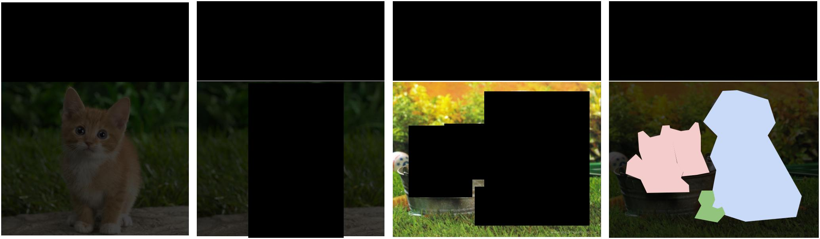

|  |  |  |  |  |  |  |  |  |  |  |  |  |  |  |
| --- | --- | --- | --- | --- | --- | --- | --- | --- | --- | --- | --- | --- | --- | --- |
| **Classification** | **Classification** | | | | | **Object Detection** | | | | | | | **Instance** |  |
| **+ Localization** | | | | | **Segmentation** |  |
|  |  |  |  |  |  |  |  |  |
|  |  |  |  |  |  |  |  |  |  |  |  |  |  |  |
|  |  |  |  |  |  |  |  |  |  |  |  |  |  |  |
|  |  |  |  |  |  |  |  |  |  |  |  |  |  |  |
|  |  |  |  |  |  |  |  |  |  |  |  |  |  |  |
|  |  |  |  |  |  |  |  |  |  |  |  |  |  |  |
|  |  |  |  |  |  |  |  |  |  |  |  |  |  |  |
|  |  |  |  |  |  |  |  |  |  |  |  |  |  |  |
|  |  |  |  |  |  |  |  |  |  |  |  |  |  |  |
|  |  |  |  |  |  |  |  |  |  |  |  |  |  |  |
|  |  |  |  |  |  |  |  |  |  |  |  |  |  |  |



Fei-Fei Li & Andrej Karpathy & Justin Johnson Lecture 8 37 1 Feb 2016

Detection as Regression?



DOG, (x, y, w, h)

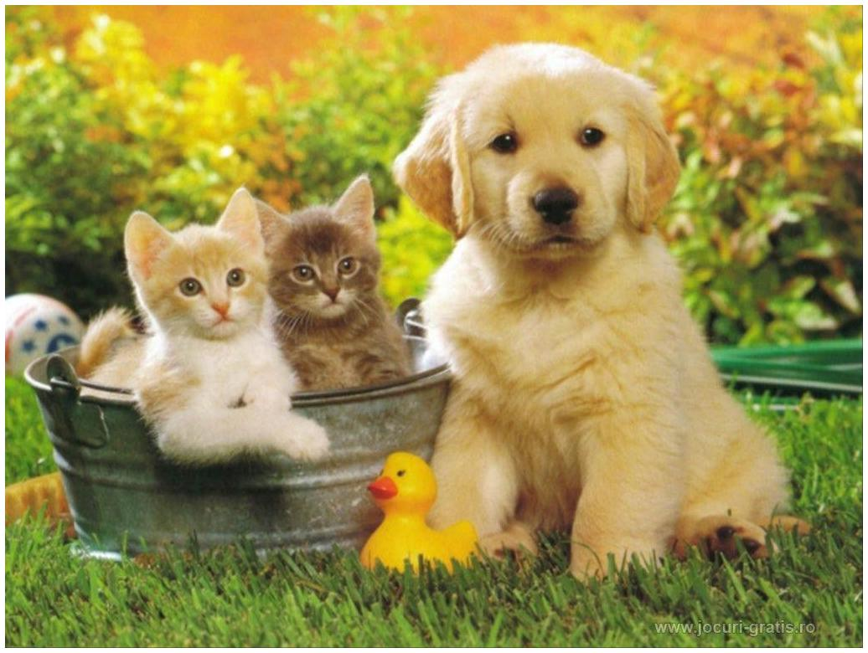

CAT, (x, y, w, h)

CAT, (x, y, w, h)



DUCK (x, y, w, h)



= 16 numbers



Fei-Fei Li & Andrej Karpathy & Justin Johnson Lecture 8 38 1 Feb 2016

Detection as Regression?



DOG, (x, y, w, h)

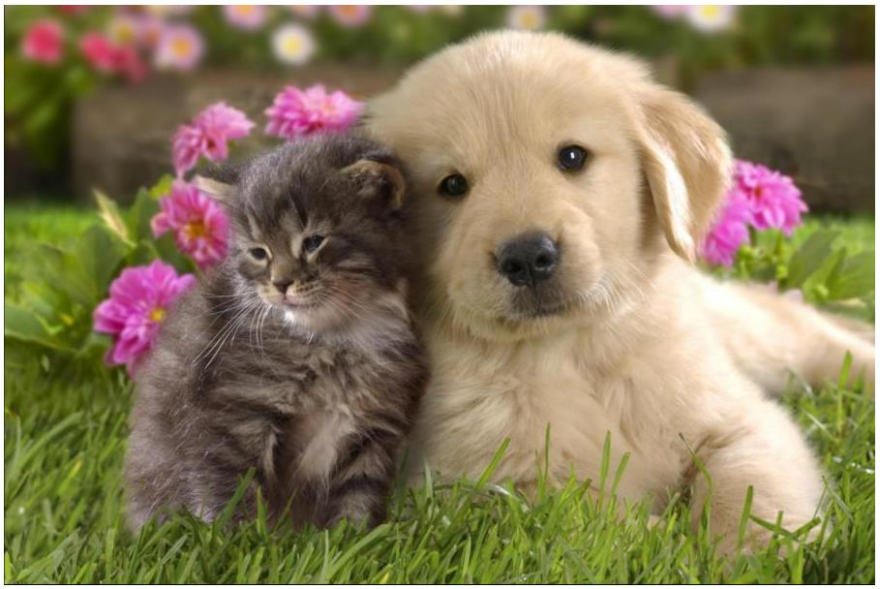

CAT, (x, y, w, h)



= 8 numbers



Fei-Fei Li & Andrej Karpathy & Justin Johnson Lecture 8 39 1 Feb 2016

Detection as Regression?



CAT, (x, y, w, h)

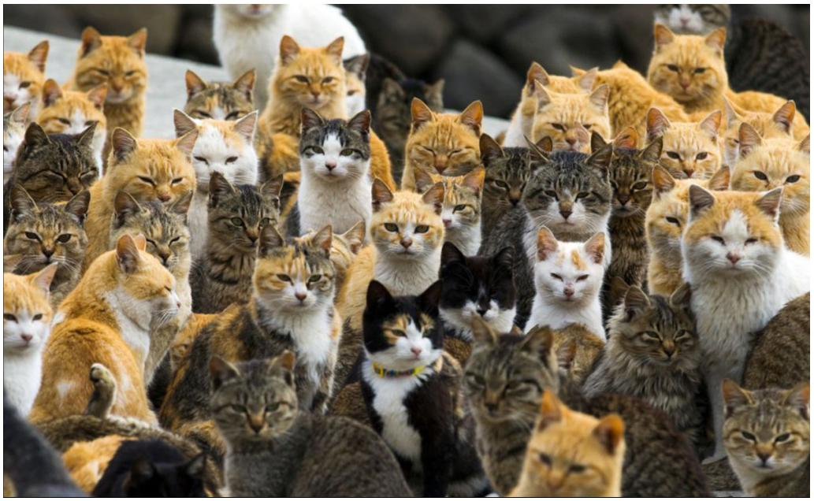

CAT, (x, y, w, h)

….



CAT (x, y, w, h)



= many numbers

Need variable sized outputs



Fei-Fei Li & Andrej Karpathy & Justin Johnson Lecture 8 40 1 Feb 2016

Detection as Classification



**CAT? NO**

**DOG? NO**



Fei-Fei Li & Andrej Karpathy & Justin Johnson Lecture 8 41 1 Feb 2016

Detection as Classification



**CAT? YES!**

**DOG? NO**



Fei-Fei Li & Andrej Karpathy & Justin Johnson Lecture 8 42 1 Feb 2016

Detection as Classification



**CAT? NO**

**DOG? NO**



Fei-Fei Li & Andrej Karpathy & Justin Johnson Lecture 8 43 1 Feb 2016

Detection as Classification



**Problem**: Need to test many positions and scales

**Solution:** If your classifier is fast enough, just do it



Fei-Fei Li & Andrej Karpathy & Justin Johnson Lecture 8 44 1 Feb 2016

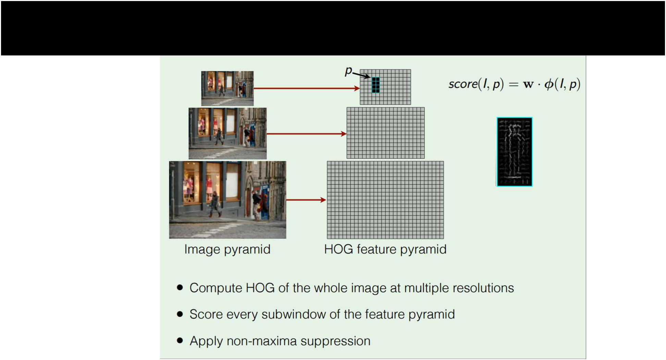Histogram of Oriented Gradients



Dalal and Triggs, “Histograms of Oriented Gradients for Human Detection”, CVPR 2005 Slide credit: Ross Girshick

Fei-Fei Li & Andrej Karpathy & Justin Johnson Lecture 8 45 1 Feb 2016

Deformable Parts Model (DPM)

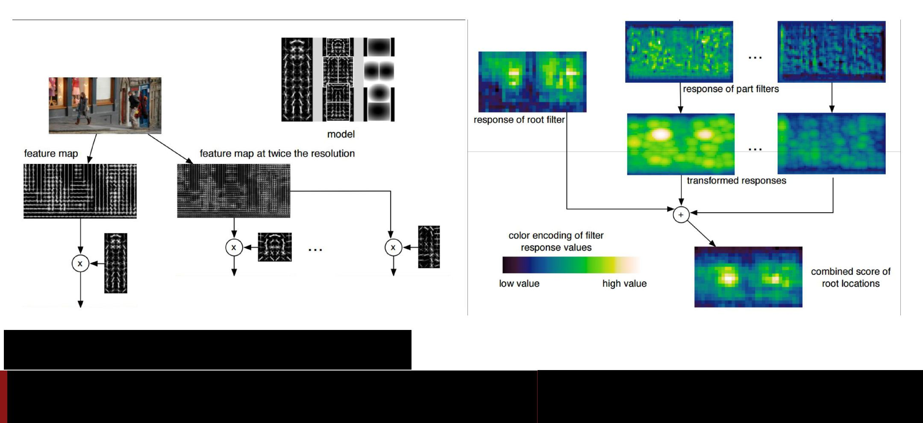

Felzenszwalb et al, “Object Detection with Discriminatively

Trained Part Based Models”, PAMI 2010

Fei-Fei Li & Andrej Karpathy & Justin Johnson Lecture 8 46 1 Feb 2016

Aside: Deformable Parts Models are CNNs?

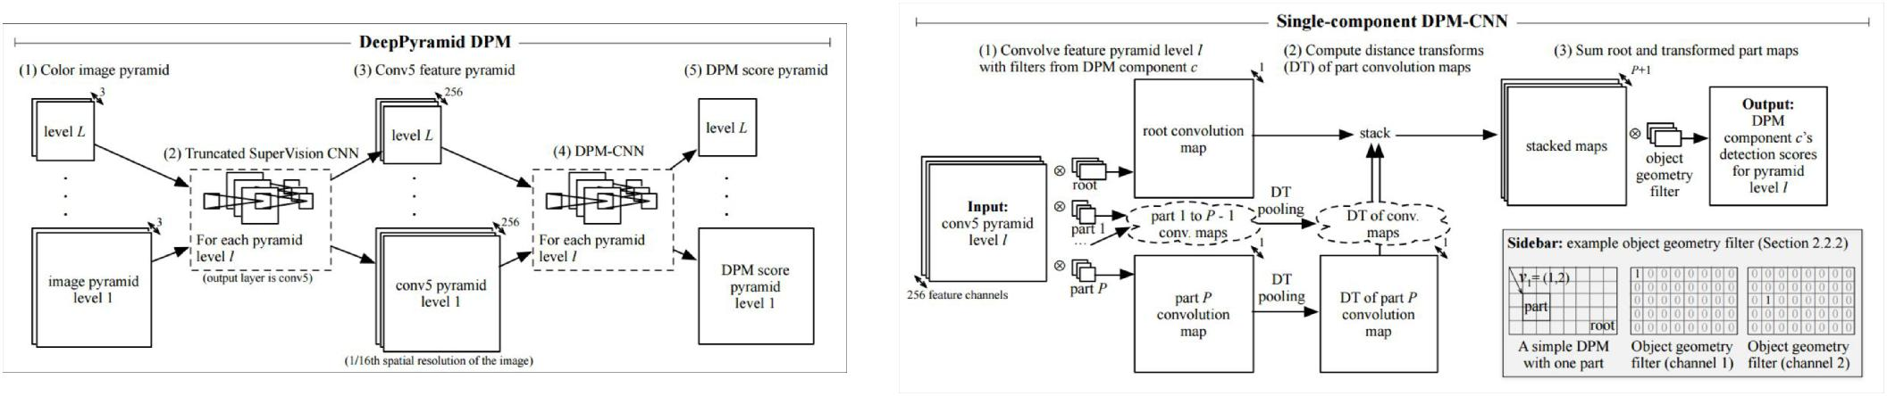

Girschick et al, “Deformable Part Models are Convolutional Neural Networks”, CVPR 2015

Fei-Fei Li & Andrej Karpathy & Justin Johnson Lecture 8 47 1 Feb 2016

Detection as Classification



**Problem**: Need to test many positions and scales,and use a computationally demanding classifier (CNN)

**Solution:** Only look at a tiny subset of possible positions



Fei-Fei Li & Andrej Karpathy & Justin Johnson Lecture 8 48 1 Feb 2016

Region Proposals



* Find “blobby” image regions that are likely to contain objects
* “Class-agnostic” object detector
* Look for “blob-like” regions

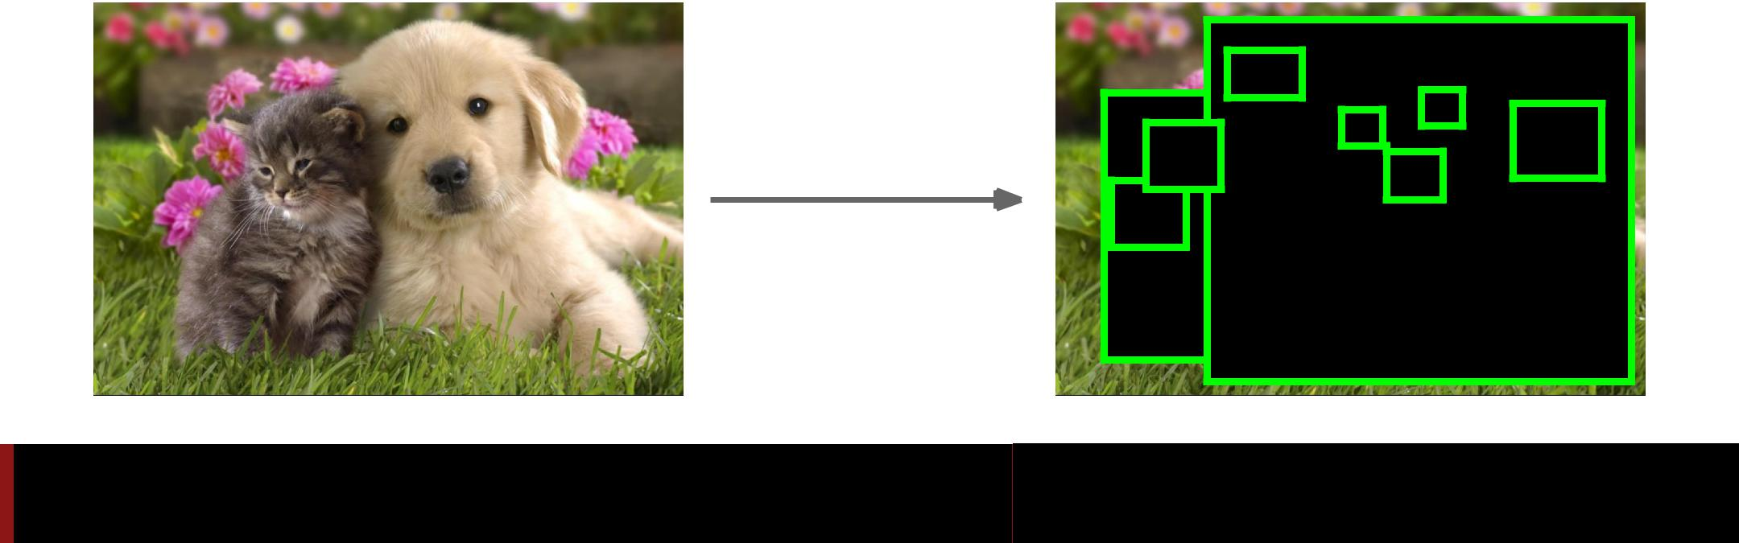

Fei-Fei Li & Andrej Karpathy & Justin Johnson Lecture 8 49 1 Feb 2016

Region Proposals: Selective Search



Bottom-up segmentation, merging regions at multiple scales

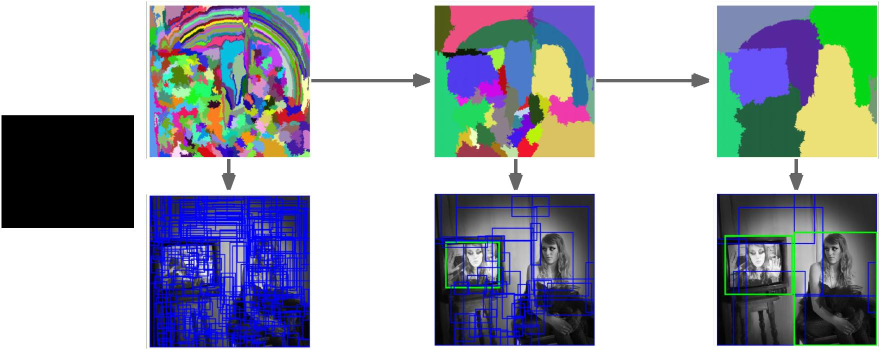

Convert



regions

to boxes



Uijlings et al, “Selective Search for Object Recognition”, IJCV 2013

Fei-Fei Li & Andrej Karpathy & Justin Johnson Lecture 8 50 1 Feb 2016

Region Proposals: Many other choices

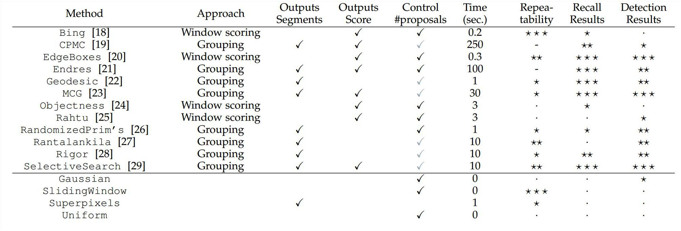

Hosang et al, “What makes for effective detection proposals?”, PAMI 2015

Fei-Fei Li & Andrej Karpathy & Justin Johnson Lecture 8 51 1 Feb 2016

Region Proposals: Many other choices

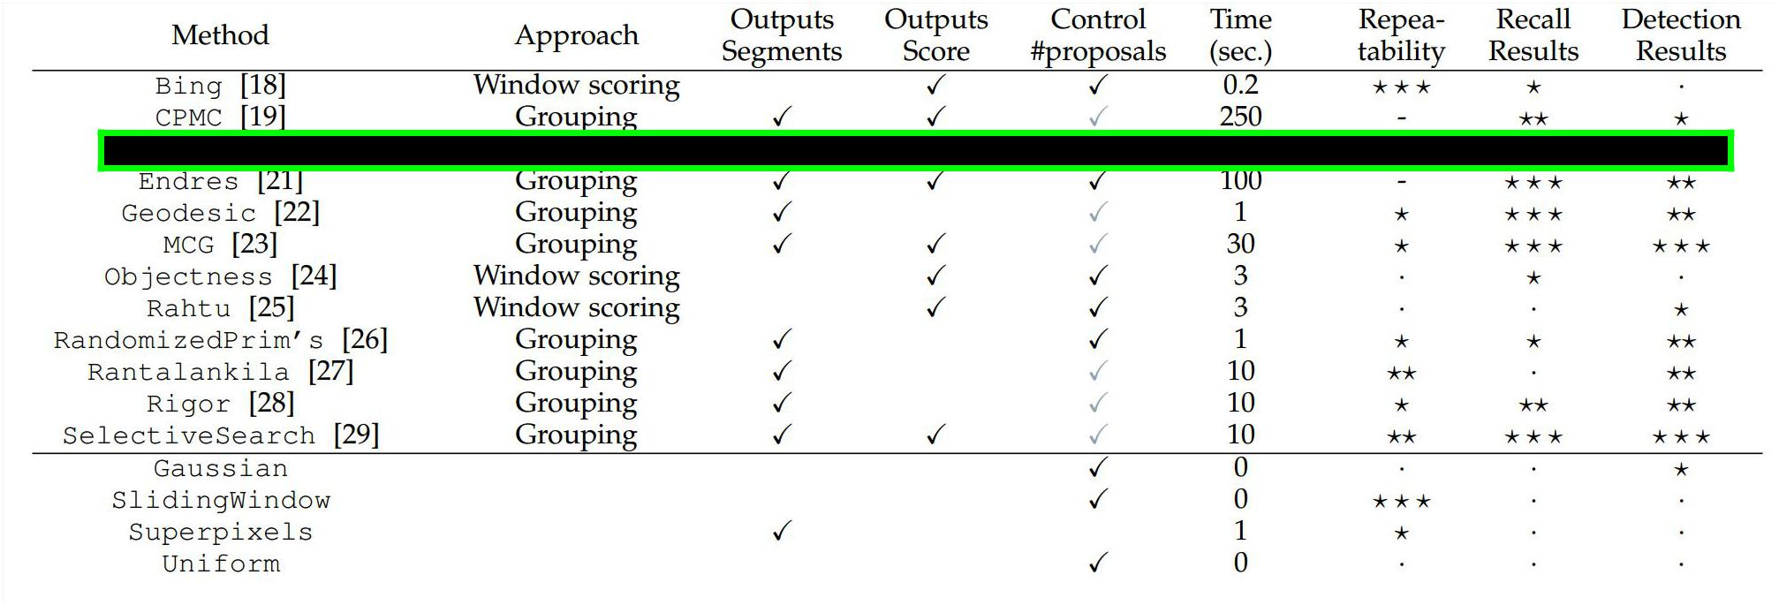

Hosang et al, “What makes for effective detection proposals?”, PAMI 2015

Fei-Fei Li & Andrej Karpathy & Justin Johnson Lecture 8 52 1 Feb 2016

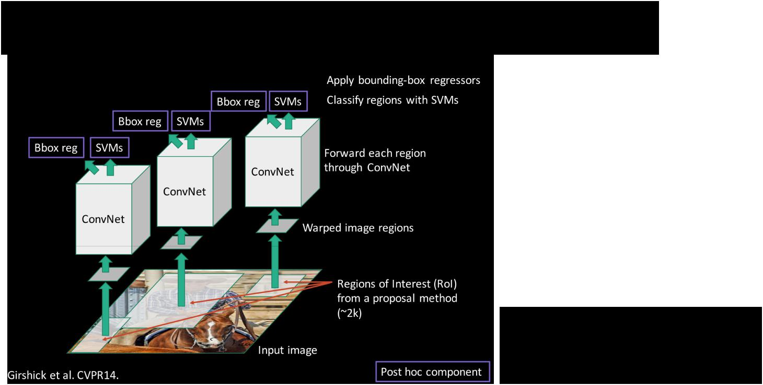Putting it together: R-CNN

Girschick et al, “Rich feature hierarchies for accurate object detection and semantic segmentation”, CVPR 2014

Slide credit: Ross Girschick



Fei-Fei Li & Andrej Karpathy & Justin Johnson Lecture 8 53 1 Feb 2016

R-CNN Training

**Step 1**: Train (or download) a classification model for ImageNet (AlexNet)

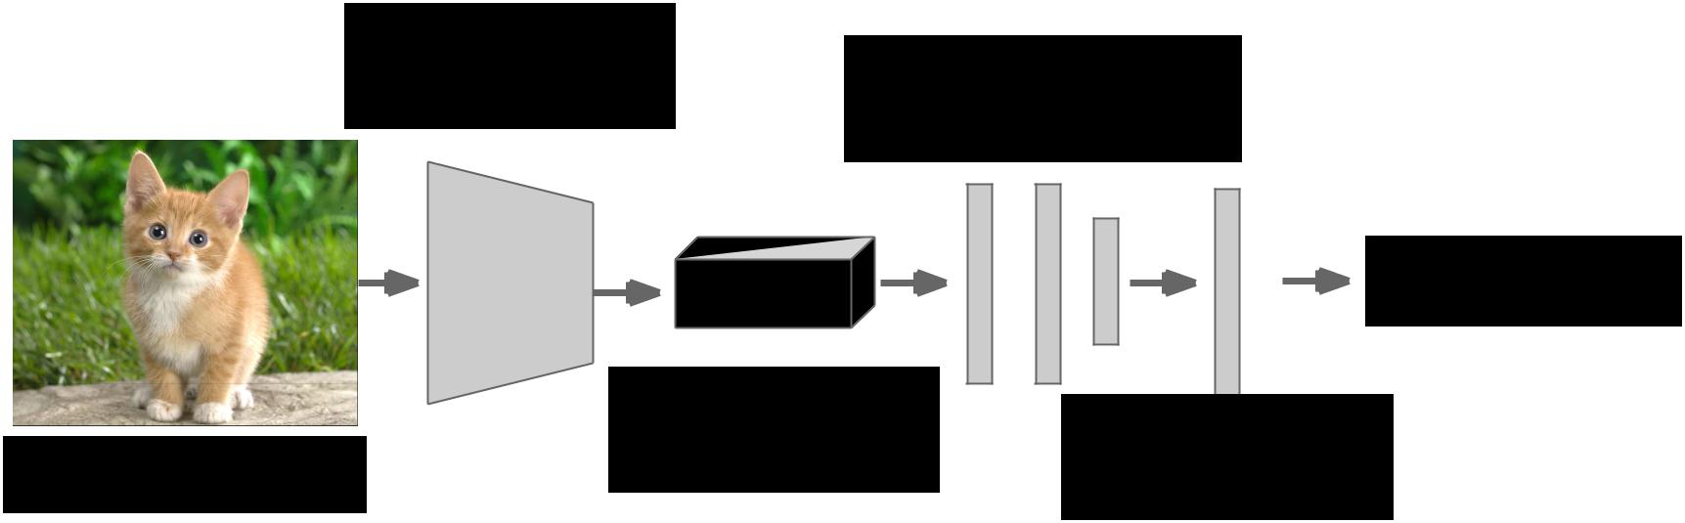

Convolution

and Pooling Fully-connected

layers

Softmax loss



|  |  |  |  |  |  |
| --- | --- | --- | --- | --- | --- |
|  | Final conv |  |  |  |  |
|  | Class scores | | |  |
| Image | feature map |  |
| 1000 classes | | |  |
|  |  |



Fei-Fei Li & Andrej Karpathy & Justin Johnson Lecture 8 54 1 Feb 2016

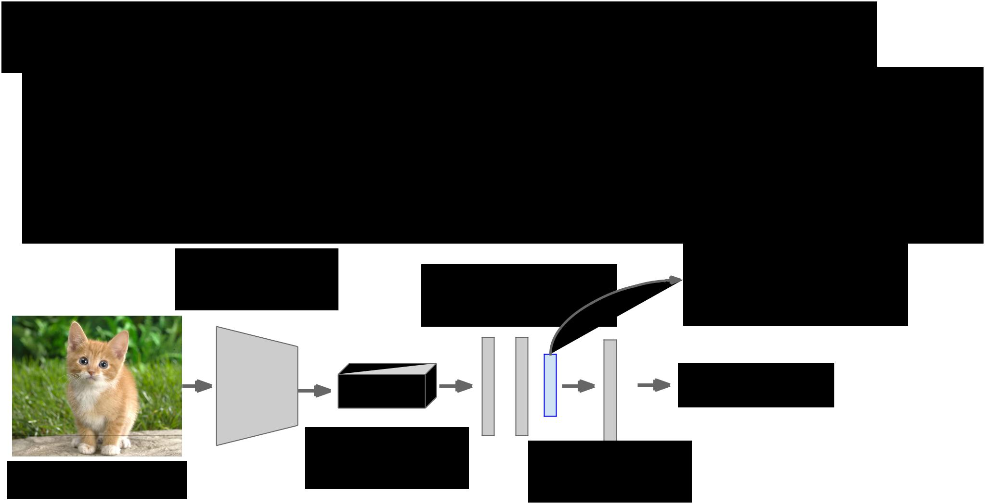R-CNN Training

**Step 2**: Fine-tune model for detection

* Instead of 1000 ImageNet classes, want 20 object classes + background
* Throw away final fully-connected layer, reinitialize from scratch
* Keep training model using positive / negative regions from detection images

|  |  |  |  |
| --- | --- | --- | --- |
| Convolution |  | Re-initialize this layer: |  |
| Fully-connected | was 4096 x 1000, |  |
| and Pooling | now will be 4096 x 21 |  |
| layers |  |
|  |  |  |

Softmax loss



|  |  |  |  |  |  |
| --- | --- | --- | --- | --- | --- |
|  | Final conv |  |  |  |  |
|  | Class scores: | | |  |
| Image | feature map |  |
| 21 classes | | |  |
|  |  |



Fei-Fei Li & Andrej Karpathy & Justin Johnson Lecture 8 55 1 Feb 2016

R-CNN Training

**Step 3**: Extract features

* Extract region proposals for all images
* For each region: warp to CNN input size, run forward through CNN, save pool5 features to disk
* Have a big hard drive: features are ~200GB for PASCAL dataset!



Convolution

and Pooling

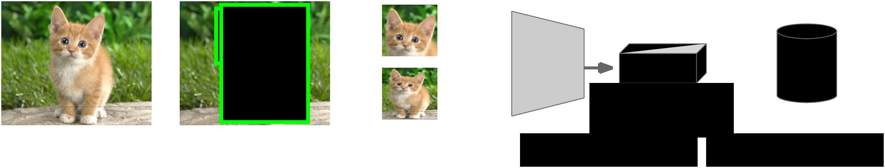

pool5 features



Image Region Proposals Crop + Warp Forward pass Save to disk



Fei-Fei Li & Andrej Karpathy & Justin Johnson Lecture 8 56 1 Feb 2016

R-CNN Training

**Step 4**: Train one binary SVM per class to classify region features



Training image regions



Cached region features



Positive samples for cat SVM Negative samples for cat SVM



Fei-Fei Li & Andrej Karpathy & Justin Johnson Lecture 8 57 1 Feb 2016

R-CNN Training

**Step 4**: Train one binary SVM per class to classify region features



Training image regions



Cached region features



Negative samples for dog SVM Positive samples for dog SVM



Fei-Fei Li & Andrej Karpathy & Justin Johnson Lecture 8 58 1 Feb 2016

R-CNN Training

**Step 5** (bbox regression): For each class, train a linear regression model to map fromcached features to offsets to GT boxes to make up for “slightly wrong” proposals



Training image regions



Cached region features



|  |  |  |  |
| --- | --- | --- | --- |
| Regression targets | (0, 0, 0, 0) | (.25, 0, 0, 0) | (0, 0, -0.125, 0) |
| (dx, dy, dw, dh) | Proposal is good | Proposal too | Proposal too |
| Normalized coordinates |  | far to left | wide |



Fei-Fei Li & Andrej Karpathy & Justin Johnson Lecture 8 59 1 Feb 2016

Object Detection: Datasets

|  |  |  |  |  |
| --- | --- | --- | --- | --- |
|  | PASCAL | ImageNet | MS-COCO |  |
|  | VOC | Detection |  |
|  | (2014) |  |
|  | (2010) | (ILSVRC 2014) |  |
|  |  |  |
|  |  |  |  |  |
| Number of | 20 | **200** | 80 |  |
| classes |  |
|  |  |  |  |
|  |  |  |  |  |
| Number of |  | **~470k** |  |  |
| images (train + | ~20k | ~120k |  |
| val) |  |  |  |  |
|  |  |  |  |  |
| Mean objects per | 2.4 | 1.1 | **7.2** |  |
| image |  |
|  |  |  |  |
|  |  |  |  |  |



Fei-Fei Li & Andrej Karpathy & Justin Johnson Lecture 8 60 1 Feb 2016

Object Detection: Evaluation



We use a metric called “mean average precision” (mAP)

Compute average precision (AP) separately for each class, then average over classes

A detection is a true positive if it has IoU with a ground-truth box greater than some threshold (usually 0.5) (mAP@0.5)

Combine all detections from all test images to draw a precision / recall curve for each class; AP is area under the curve

TL;DR mAP is a number from 0 to 100; high is good



Fei-Fei Li & Andrej Karpathy & Justin Johnson Lecture 8 61 1 Feb 2016

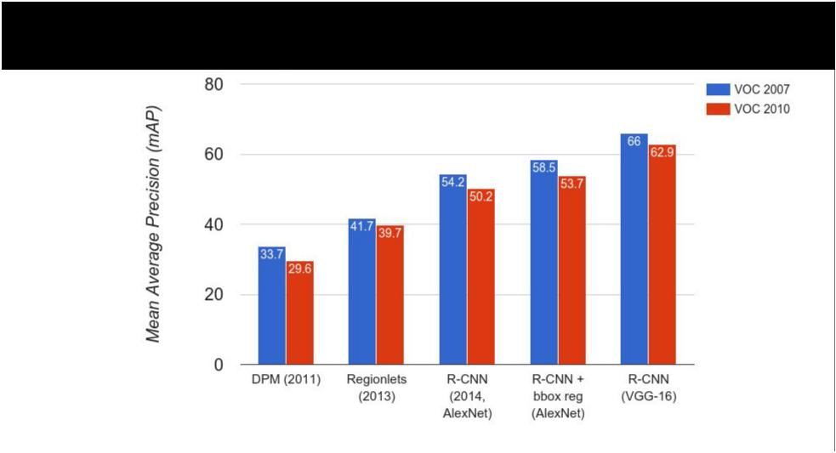R-CNN Results



Wang et al, “Regionlets for Generic Object Detection”, ICCV 2013

Fei-Fei Li & Andrej Karpathy & Justin Johnson Lecture 8 62 1 Feb 2016

|  |  |  |
| --- | --- | --- |
| R-CNN Results | Big improvement compared |  |
|  |  |
|  | to pre-CNN methods |  |

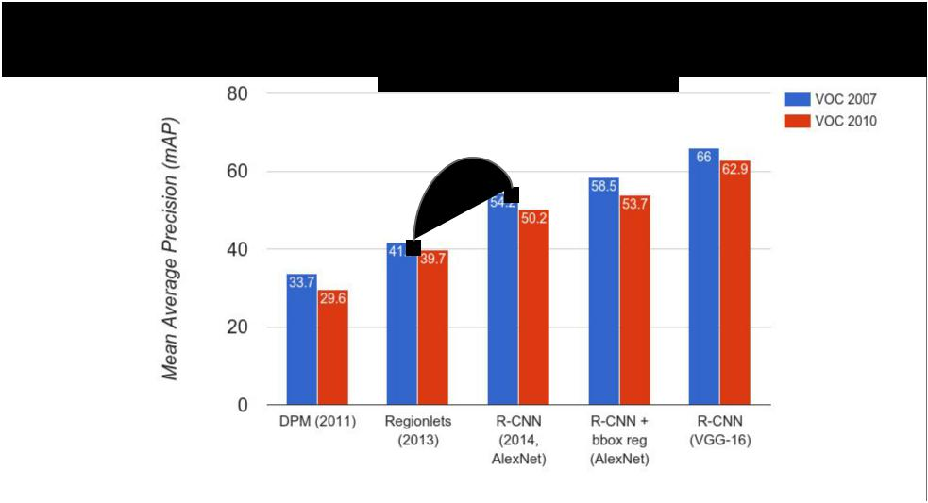

Fei-Fei Li & Andrej Karpathy & Justin Johnson Lecture 8 63 1 Feb 2016

|  |  |  |
| --- | --- | --- |
| R-CNN Results | Bounding box regression |  |
|  |  |
|  | helps a bit |  |

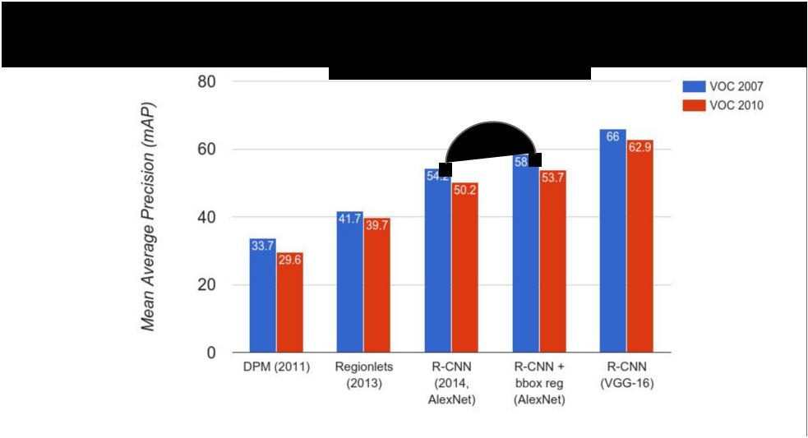

Fei-Fei Li & Andrej Karpathy & Justin Johnson Lecture 8 64 1 Feb 2016

|  |  |  |
| --- | --- | --- |
| R-CNN Results | Features from a deeper |  |
|  |  |
|  | network help a lot |  |

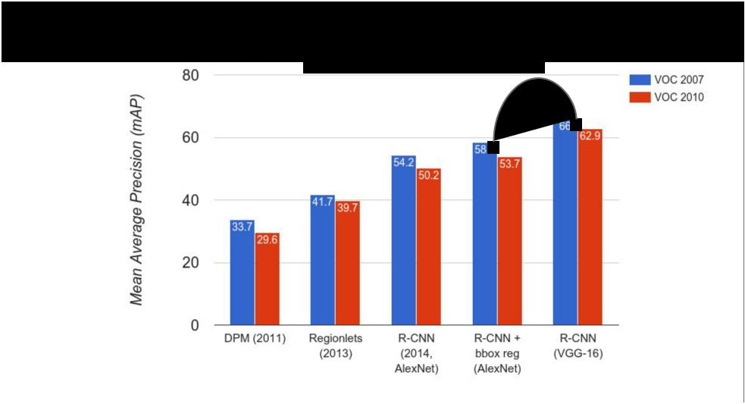

Fei-Fei Li & Andrej Karpathy & Justin Johnson Lecture 8 65 1 Feb 2016

R-CNN Problems



1. Slow at test-time: need to run full forward pass of CNN for each region proposal
2. SVMs and regressors are post-hoc: CNN features not updated in response to SVMs and regressors
3. Complex multistage training pipeline



Fei-Fei Li & Andrej Karpathy & Justin Johnson Lecture 8 66 1 Feb 2016

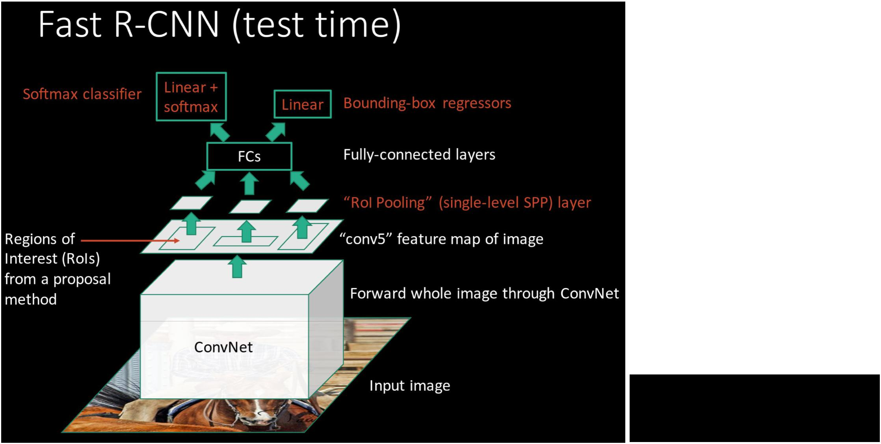

Girschick, “Fast R-CNN”, ICCV 2015

Slide credit: Ross Girschick



Fei-Fei Li & Andrej Karpathy & Justin Johnson Lecture 8 67 1 Feb 2016

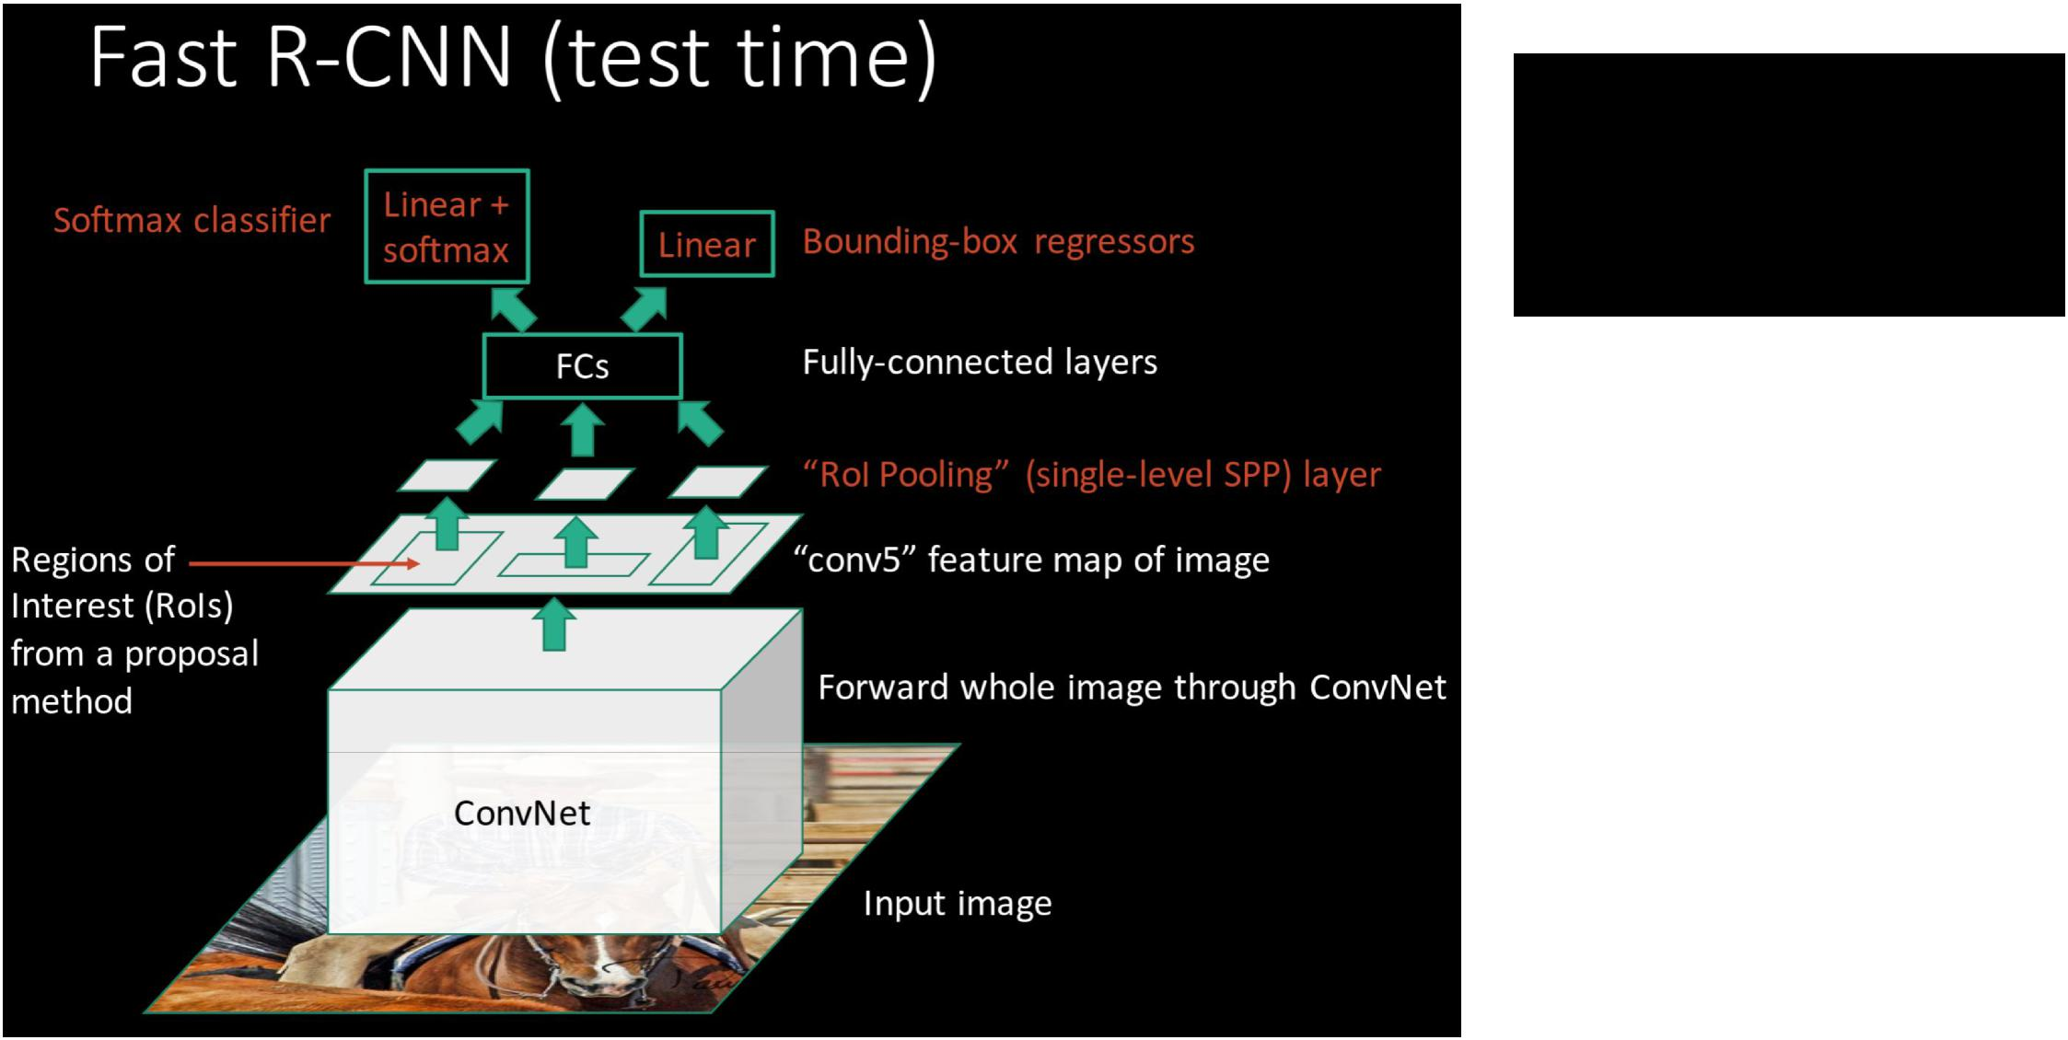**R-CNN Problem #1**:Slow at test-time due to independent forward passes of the CNN



**Solution:**

Share computation of convolutional layers between proposals for an image



Fei-Fei Li & Andrej Karpathy & Justin Johnson Lecture 8 68 1 Feb 2016

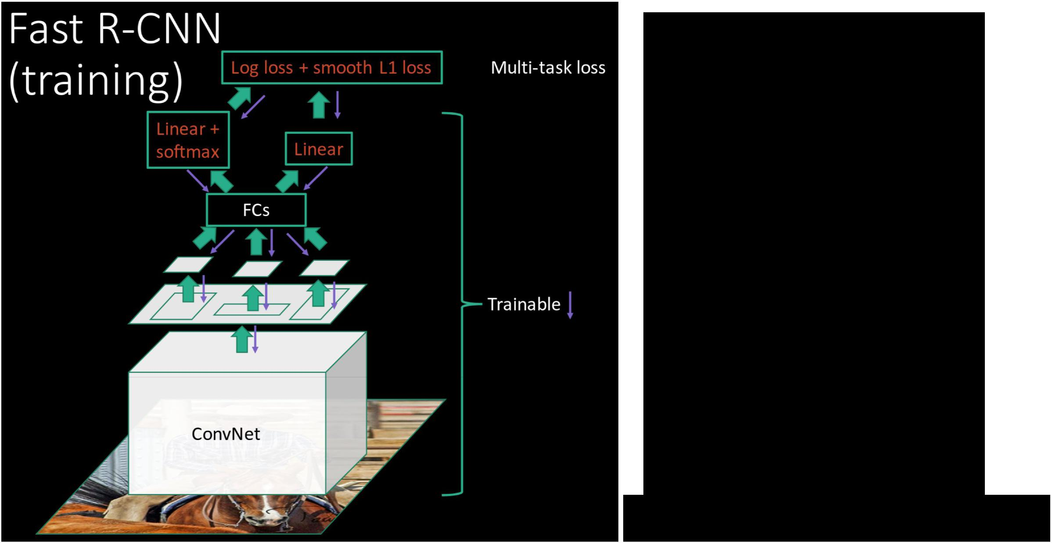**R-CNN Problem #2**:Post-hoc training: CNN not updated in response to final classifiers and regressors

**R-CNN Problem #3:**

Complex training pipeline

**Solution:**

Just train the whole system end-to-end all at once!

Slide credit: Ross Girschick



Fei-Fei Li & Andrej Karpathy & Justin Johnson Lecture 8 69 1 Feb 2016

Fast R-CNN: Region of Interest Pooling

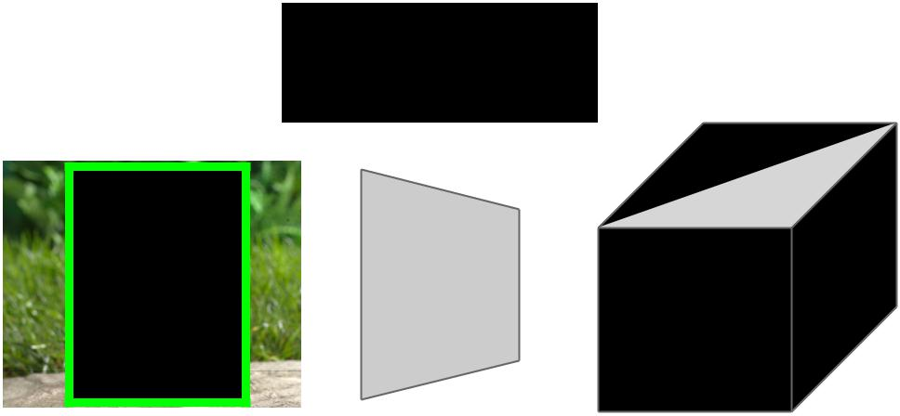

|  |  |  |  |  |  |  |  |  |
| --- | --- | --- | --- | --- | --- | --- | --- | --- |
| Convolution | Fully-connected | | | | | | |  |
| and Pooling |  |
|  |  | layers | | | | |  |
|  |  |  |  |
|  |  |  |  |  |  |  |  |  |
|  |  |  |  |  |  |  |  |  |
|  |  |  |  |  |  |  |  |  |
|  |  |  |  |  |  |  |  |  |
|  |  |  |  |  |  |  |  |  |
|  |  |  |  |  |  |  |  |  |



Hi-res input image:

3 x 800 x 600

with region

proposal

|  |  |
| --- | --- |
| Hi-res conv features: | **Problem**: Fully-connected |
| C x H x W | layers expect low-res conv |
| with region proposal | features: C x h x w |



Fei-Fei Li & Andrej Karpathy & Justin Johnson Lecture 8 70 1 Feb 2016

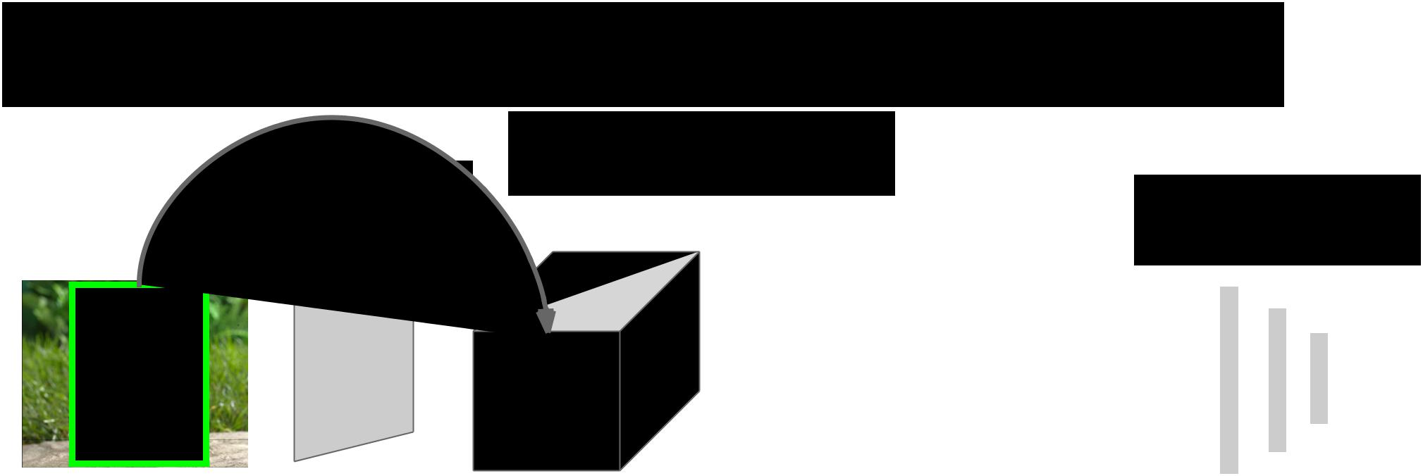Fast R-CNN: Region of Interest Pooling

|  |  |  |  |  |  |  |  |  |  |
| --- | --- | --- | --- | --- | --- | --- | --- | --- | --- |
|  | Project region proposal | | | | | | | |  |
| Convolution | onto conv feature map | | | | | | | |  |
|  | Fully-connected | | | | | | |  |
| and Pooling |  |  |
|  |  |  | layers | | | | |  |
|  |  |  |  |  |
|  |  |  |  |  |  |  |  |  |  |
|  |  |  |  |  |  |  |  |  |  |
|  |  |  |  |  |  |  |  |  |  |
|  |  |  |  |  |  |  |  |  |  |
|  |  |  |  |  |  |  |  |  |  |
|  |  |  |  |  |  |  |  |  |  |
|  |  |  |  |  |  |  |  |  |  |
|  |  |  |  |  |  |  |  |  |  |



Hi-res input image:

3 x 800 x 600

with region

proposal

|  |  |
| --- | --- |
| Hi-res conv features: | **Problem**: Fully-connected |
| C x H x W | layers expect low-res conv |
| with region proposal | features: C x h x w |



Fei-Fei Li & Andrej Karpathy & Justin Johnson Lecture 8 71 1 Feb 2016

Fast R-CNN: Region of Interest Pooling

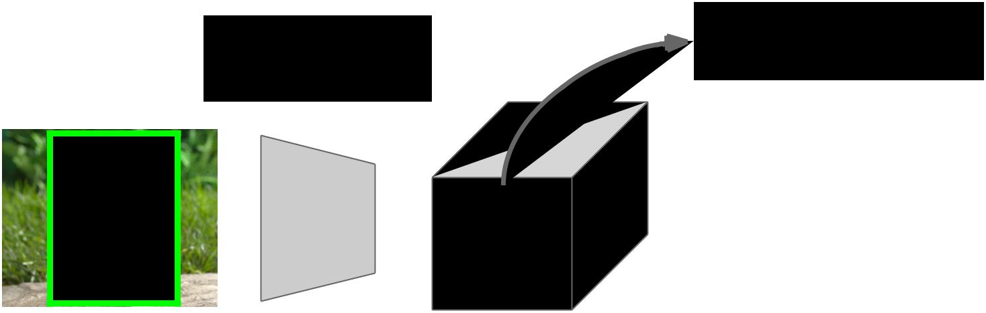

|  |  |  |  |  |  |  |  |  |  |  |  |  |  |  |
| --- | --- | --- | --- | --- | --- | --- | --- | --- | --- | --- | --- | --- | --- | --- |
| Convolution | |  |  |  |  | Divide projected | Fully-connected | | | | | | |  |
|  |  |  |  | region into h x w grid |  |
| and Pooling | |  |  |  |  |  |
|  |  |  |  |  |  |  | layers | | | | |  |
|  |  |  |  |  |  |  |  |  |  |
|  |  |  |  |  |  |  |  |  |  |  |  |  |  |  |
|  |  |  |  |  |  |  |  |  |  |  |  |  |  |  |
|  |  |  |  |  |  |  |  |  |  |  |  |  |  |  |
|  |  |  |  |  |  |  |  |  |  |  |  |  |  |  |
|  |  |  |  |  |  |  |  |  |  |  |  |  |  |  |
|  |  |  |  |  |  |  |  |  |  |  |  |  |  |  |
|  |  |  |  |  |  |  |  |  |  |  |  |  |  |  |
|  |  |  |  |  |  |  |  |  |  |  |  |  |  |  |
|  |  |  |  |  |  |  |  |  |  |  |  |  |  |  |



Hi-res input image:

3 x 800 x 600

with region

proposal

|  |  |
| --- | --- |
| Hi-res conv features: | **Problem**: Fully-connected |
| C x H x W | layers expect low-res conv |
| with region proposal | features: C x h x w |



Fei-Fei Li & Andrej Karpathy & Justin Johnson Lecture 8 72 1 Feb 2016

Fast R-CNN: Region of Interest Pooling

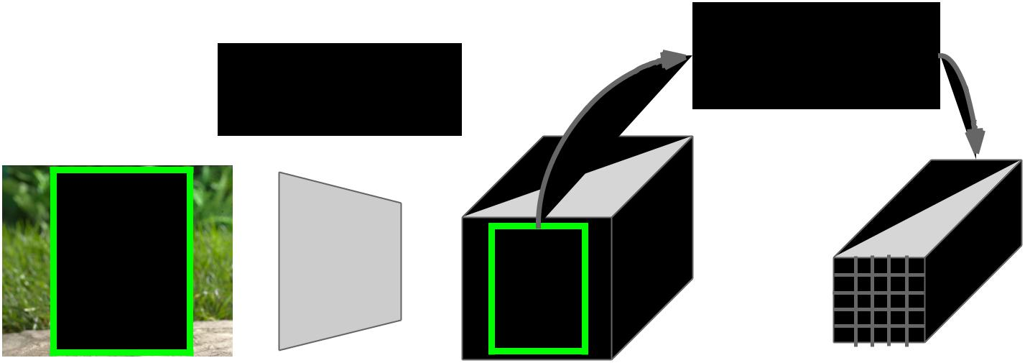

|  |  |  |
| --- | --- | --- |
|  | Max-pool within |  |
| Convolution | each grid cell |  |
| and Pooling | Fully-connected |  |
| layers |  |
|  |  |



Hi-res input image:

3 x 800 x 600

with region

proposal

Hi-res conv features:

C x H x W

with region proposal

RoI conv features:

C x h x w

for region proposal



Fully-connected layers expect low-res conv features: C x h x w

Fei-Fei Li & Andrej Karpathy & Justin Johnson Lecture 8 73 1 Feb 2016

Fast R-CNN: Region of Interest Pooling

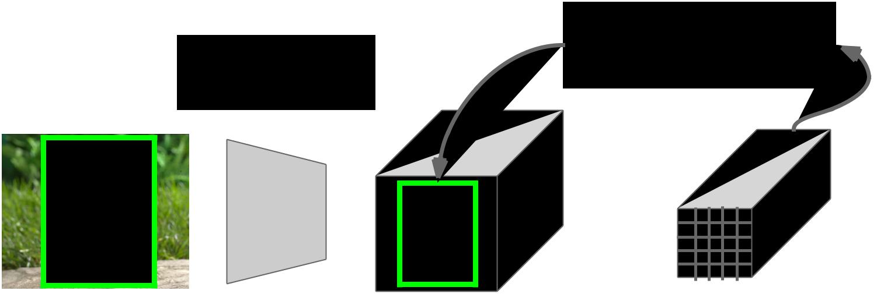

|  |  |  |
| --- | --- | --- |
|  | Can back propagate |  |
| Convolution | similar to max pooling |  |
| and Pooling | Fully-connected |  |
| layers |  |
|  |  |



Hi-res input image:

3 x 800 x 600

with region

proposal

Hi-res conv features:

C x H x W

with region proposal

RoI conv features:

C x h x w

for region proposal



Fully-connected layers expect low-res conv features: C x h x w

Fei-Fei Li & Andrej Karpathy & Justin Johnson Lecture 8 74 1 Feb 2016

Fast R-CNN Results

|  |  |  |  |  |
| --- | --- | --- | --- | --- |
|  |  | **R-CNN** | **Fast R-CNN** |  |
|  |  |  |  |  |
| Faster! | Training Time: | 84 hours | **9.5 hours** |  |
|  |  |  |  |
| (Speedup) | 1x | **8.8x** |  |
|  |  |
|  |  |  |  |  |



Using VGG-16 CNN on Pascal VOC 2007 dataset

Fei-Fei Li & Andrej Karpathy & Justin Johnson Lecture 8 75 1 Feb 2016

Fast R-CNN Results

|  |  |  |  |  |
| --- | --- | --- | --- | --- |
|  |  | **R-CNN** | **Fast R-CNN** |  |
|  |  |  |  |  |
| Faster! | Training Time: | 84 hours | **9.5 hours** |  |
|  |  |  |  |
| (Speedup) | 1x | **8.8x** |  |
|  |  |
|  |  |  |  |  |
| FASTER! | Test time per image | 47 seconds | **0.32 seconds** |  |
|  |  |  |  |
| (Speedup) | 1x | **146x** |  |
|  |  |
|  |  |  |  |  |



Using VGG-16 CNN on Pascal VOC 2007 dataset

Fei-Fei Li & Andrej Karpathy & Justin Johnson Lecture 8 76 1 Feb 2016

Fast R-CNN Results

|  |  |  |  |  |
| --- | --- | --- | --- | --- |
|  |  | **R-CNN** | **Fast R-CNN** |  |
|  |  |  |  |  |
| Faster! | Training Time: | 84 hours | **9.5 hours** |  |
|  |  |  |  |
| (Speedup) | 1x | **8.8x** |  |
|  |  |
|  |  |  |  |  |
| FASTER! | Test time per image | 47 seconds | **0.32 seconds** |  |
|  |  |  |  |
| (Speedup) | 1x | **146x** |  |
|  |  |
|  |  |  |  |  |
| Better! | mAP (VOC 2007) | 66.0 | **66.9** |  |
|  |  |  |  |  |



Using VGG-16 CNN on Pascal VOC 2007 dataset

Fei-Fei Li & Andrej Karpathy & Justin Johnson Lecture 8 77 1 Feb 2016

Fast R-CNN Problem:

Test-time speeds don’t include region proposals

|  |  |  |  |
| --- | --- | --- | --- |
|  | **R-CNN** | **Fast R-CNN** |  |
|  |  |  |  |
| Test time per image | 47 seconds | **0.32 seconds** |  |
|  |  |  |  |
| (Speedup) | 1x | **146x** |  |
|  |  |  |  |
| Test time per image | 50 seconds | **2 seconds** |  |
| with Selective Search |  |
|  |  |  |  |
| (Speedup) | 1x | **25x** |  |
|  |  |  |  |



Fei-Fei Li & Andrej Karpathy & Justin Johnson Lecture 8 78 1 Feb 2016

Fast R-CNN ~~Problem~~ Solution:

Test-time speeds don’t include region proposals Just make the CNN do region proposals too!

|  |  |  |  |
| --- | --- | --- | --- |
|  | **R-CNN** | **Fast R-CNN** |  |
|  |  |  |  |
| Test time per image | 47 seconds | **0.32 seconds** |  |
|  |  |  |  |
| (Speedup) | 1x | **146x** |  |
|  |  |  |  |
| Test time per image | 50 seconds | **2 seconds** |  |
| with Selective Search |  |
|  |  |  |  |
| (Speedup) | 1x | **25x** |  |
|  |  |  |  |



Fei-Fei Li & Andrej Karpathy & Justin Johnson Lecture 8 79 1 Feb 2016

Faster R-CNN:

Insert a **Region Proposal** **Network (RPN)** after the lastconvolutional layer

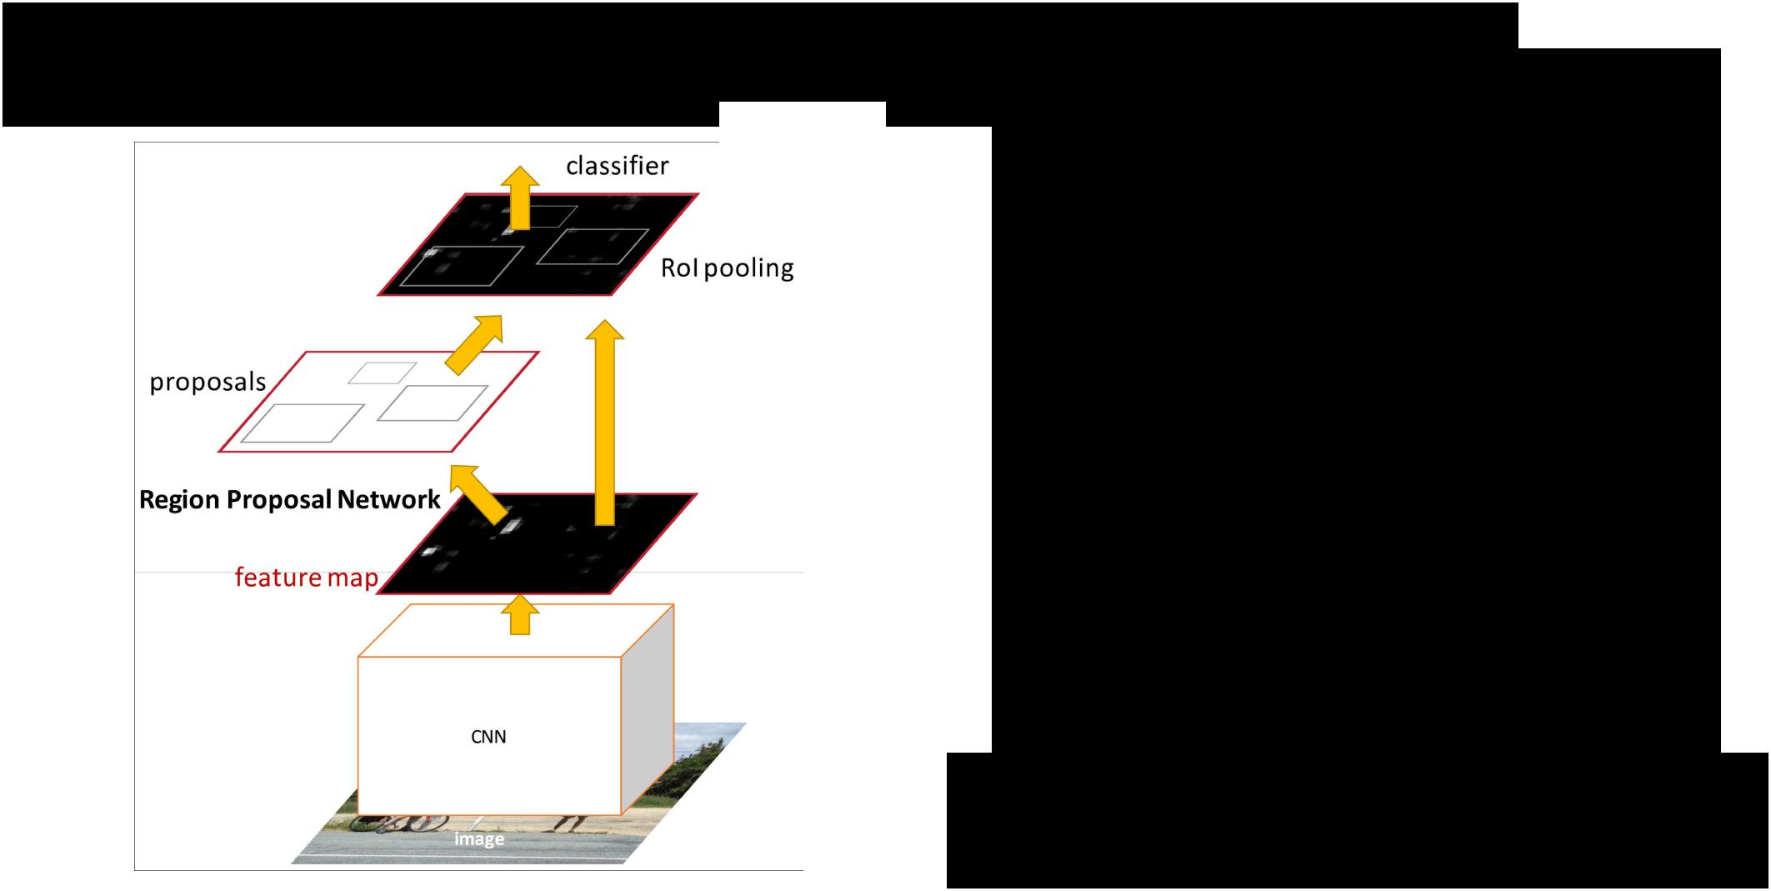

RPN trained to produce region proposals directly; no need for external region proposals!

After RPN, use RoI Pooling and an upstream classifier and bbox regressor just like Fast R-CNN

Ren et al, “Faster R-CNN: Towards Real-Time Object Detection with Region Proposal Networks”, NIPS 2015

Slide credit: Ross Girschick



Fei-Fei Li & Andrej Karpathy & Justin Johnson Lecture 8 80 1 Feb 2016

Faster R-CNN: Region Proposal Network

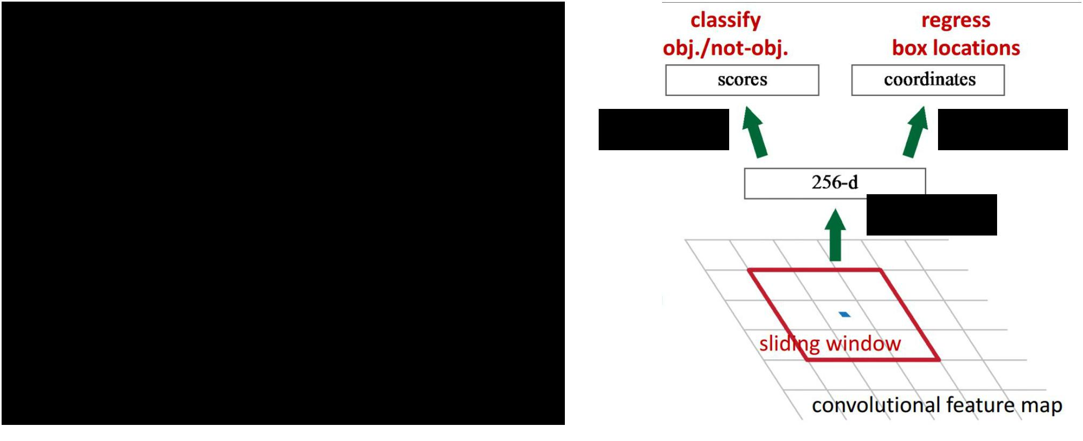

Slide a small window on the feature map

|  |  |  |  |
| --- | --- | --- | --- |
| Build a small network for: |  |  |  |
| • classifying object or not-object, and | 1 x 1 conv | 1 x 1 conv |  |
| • regressing bbox locations |  |  |  |
| Position of the sliding window provides localization |  | 1 x 1 conv |  |
|  |  |  |
| information with reference to the image |  |  |  |
| Box regression provides finer localization information |  |  |  |
| with reference to this sliding window |  |  |  |



Slide credit: Kaiming He

Fei-Fei Li & Andrej Karpathy & Justin Johnson Lecture 8 81 1 Feb 2016

Faster R-CNN: Region Proposal Network

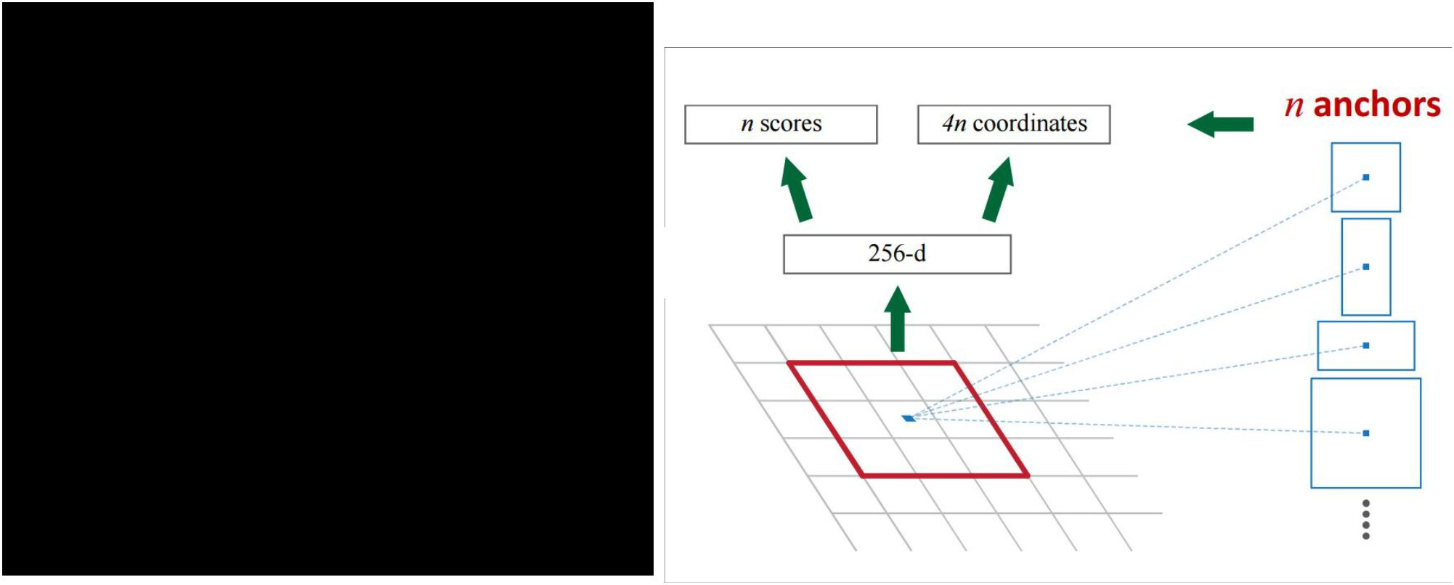

Use **N anchor boxes** at each location

Anchors are **translation invariant**: use the same ones at every location

Regression gives offsets from anchor boxes

Classification gives the probability that each (regressed) anchor shows an object



Fei-Fei Li & Andrej Karpathy & Justin Johnson Lecture 8 82 1 Feb 2016

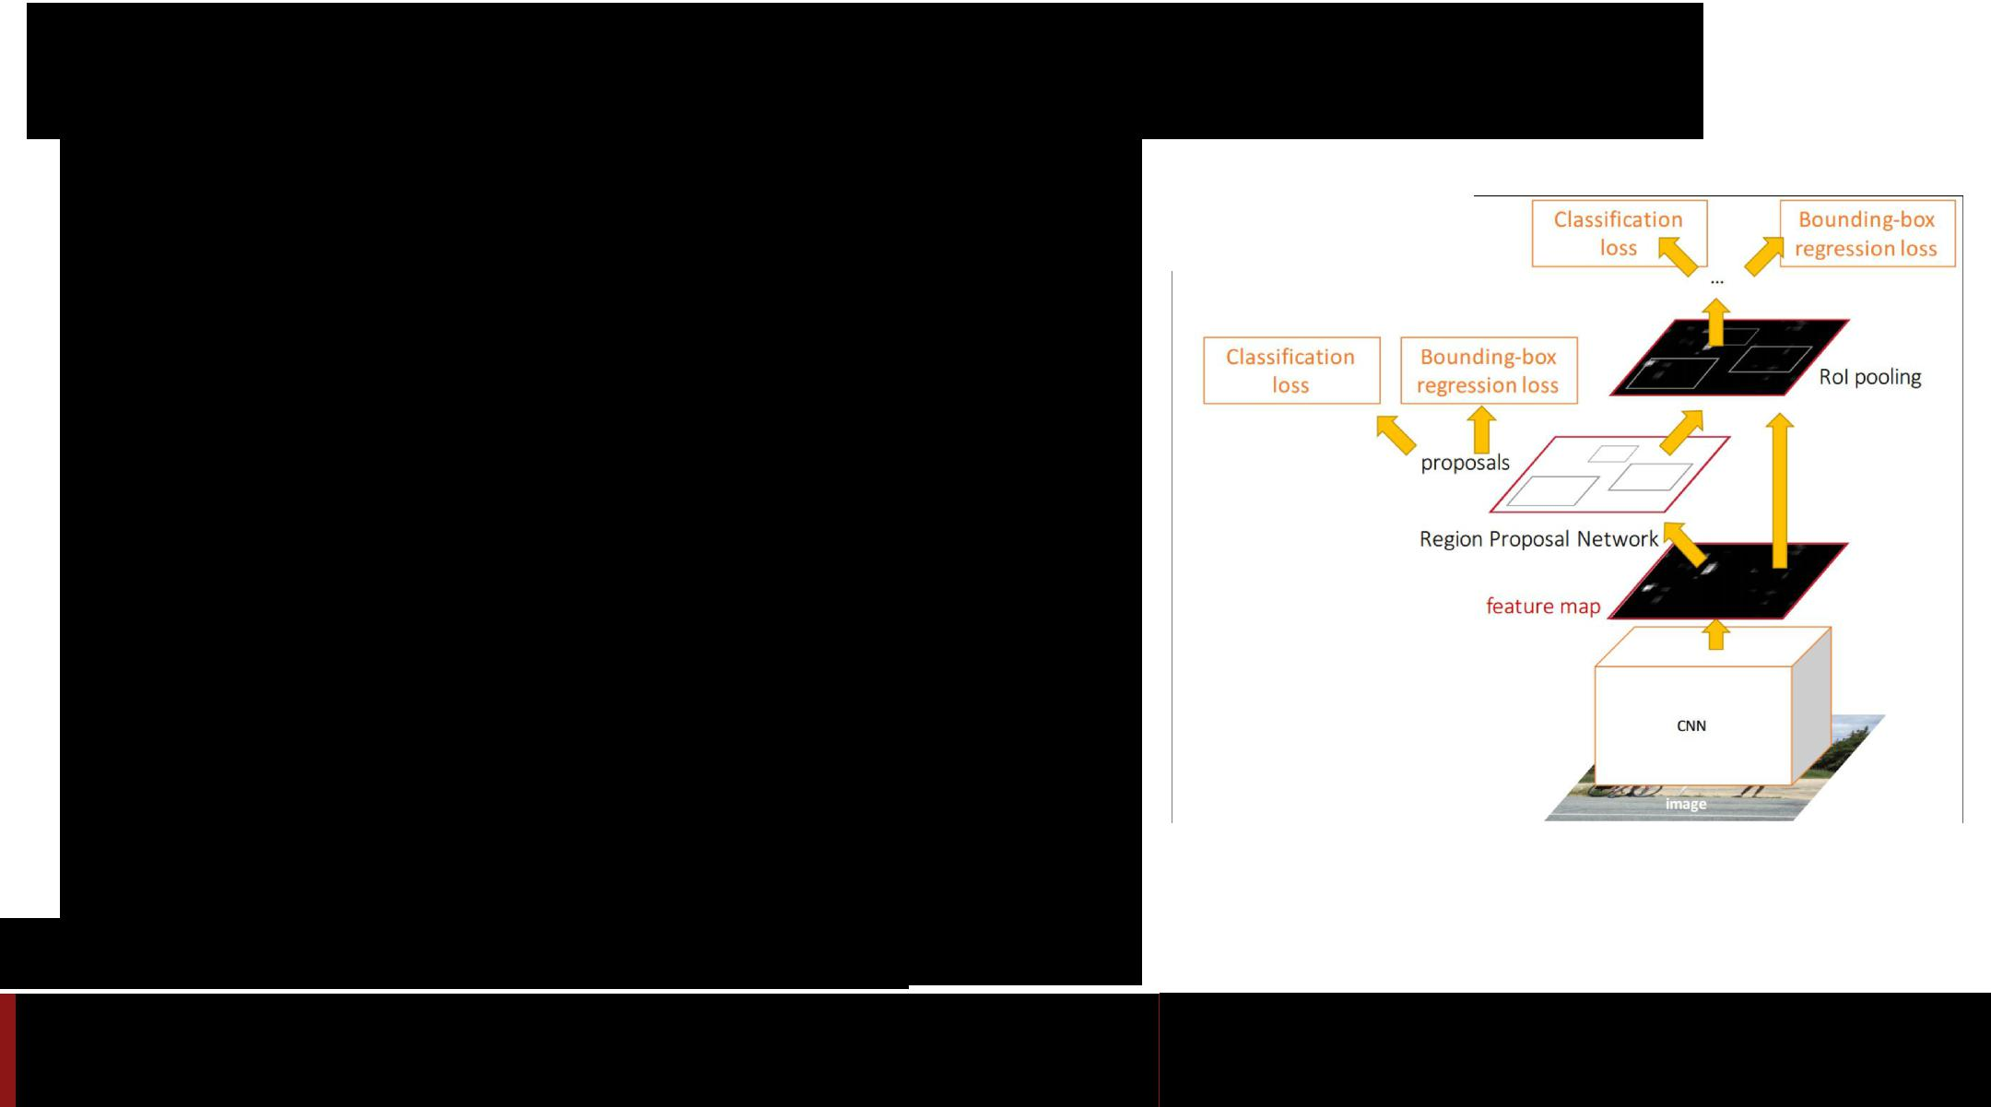Faster R-CNN: Training

In the paper: Ugly pipeline

* Use alternating optimization to train RPN, then Fast R-CNN with RPN proposals, etc.
* More complex than it has to be

Since publication: Joint training!

One network, four losses

* RPN classification (anchor good / bad)
* RPN regression (anchor -> proposal)
* Fast R-CNN classification (over classes)
* Fast R-CNN regression (proposal -> box)

Slide credit: Ross Girschick

Fei-Fei Li & Andrej Karpathy & Justin Johnson Lecture 8 83 1 Feb 2016

Faster R-CNN: Results

|  |  |  |  |
| --- | --- | --- | --- |
|  | **R-CNN** | **Fast R-CNN** | **Faster R-CNN** |
|  |  |  |  |
| Test time per | 50 seconds | 2 seconds | **0.2 seconds** |
| image |  |  |  |
| (with proposals) |  |  |  |
|  |  |  |  |
| (Speedup) | 1x | 25x | **250x** |
|  |  |  |  |
| mAP (VOC 2007) | 66.0 | **66.9** | **66.9** |
|  |  |  |  |



Fei-Fei Li & Andrej Karpathy & Justin Johnson Lecture 8 84 1 Feb 2016

Object Detection State-of-the-art:

ResNet 101 + Faster R-CNN + some extras

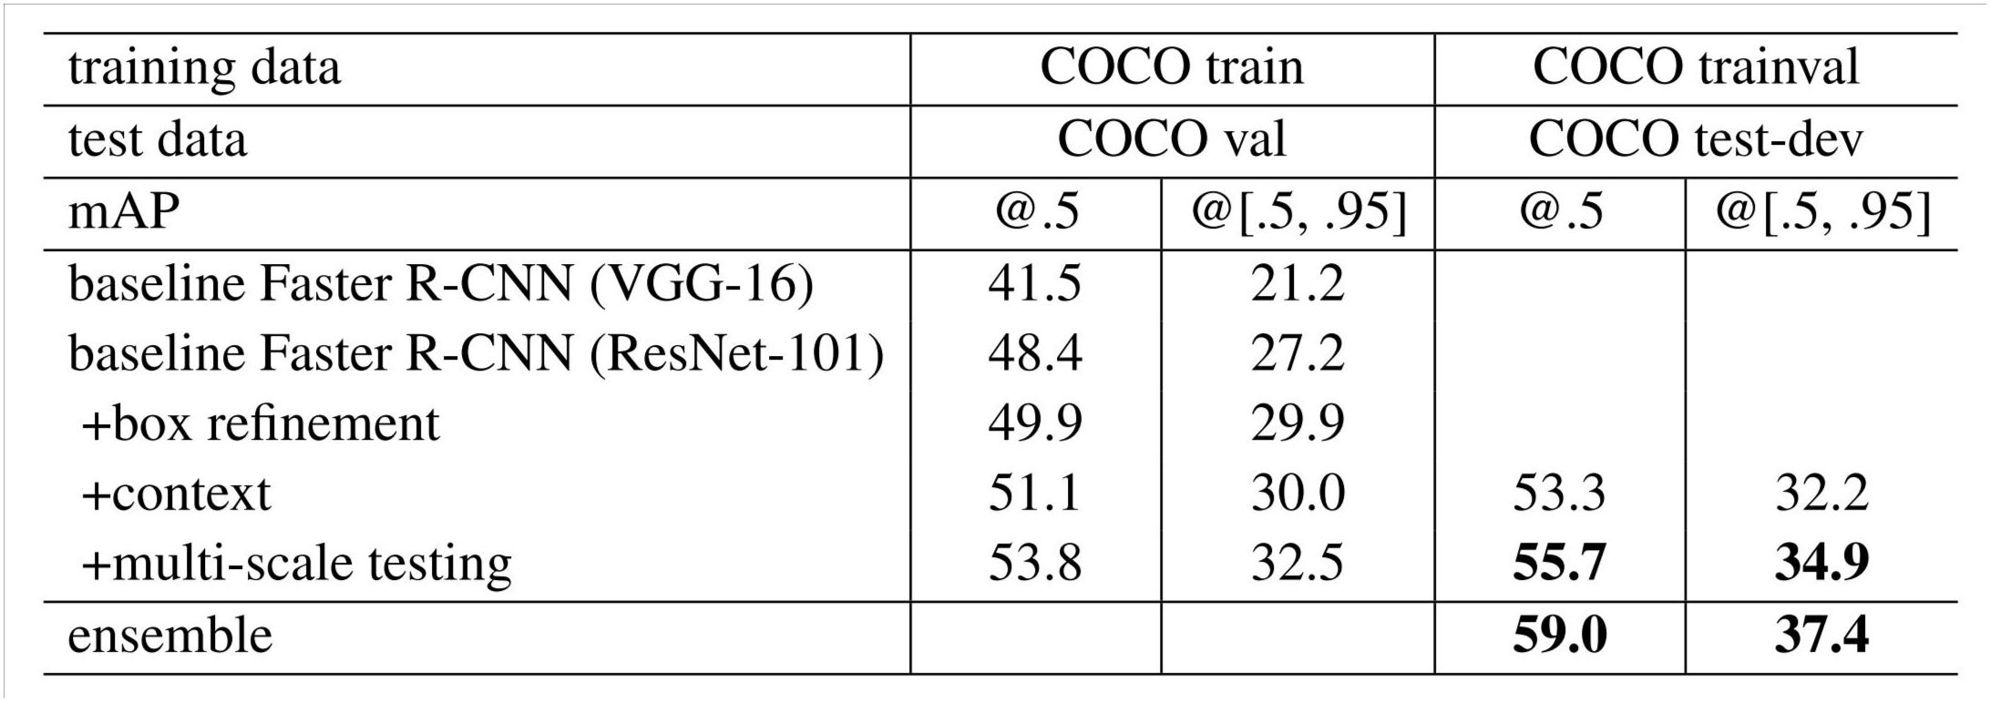

He et. al, “Deep Residual Learning for Image Recognition”, arXiv 2015

Fei-Fei Li & Andrej Karpathy & Justin Johnson Lecture 8 85 1 Feb 2016

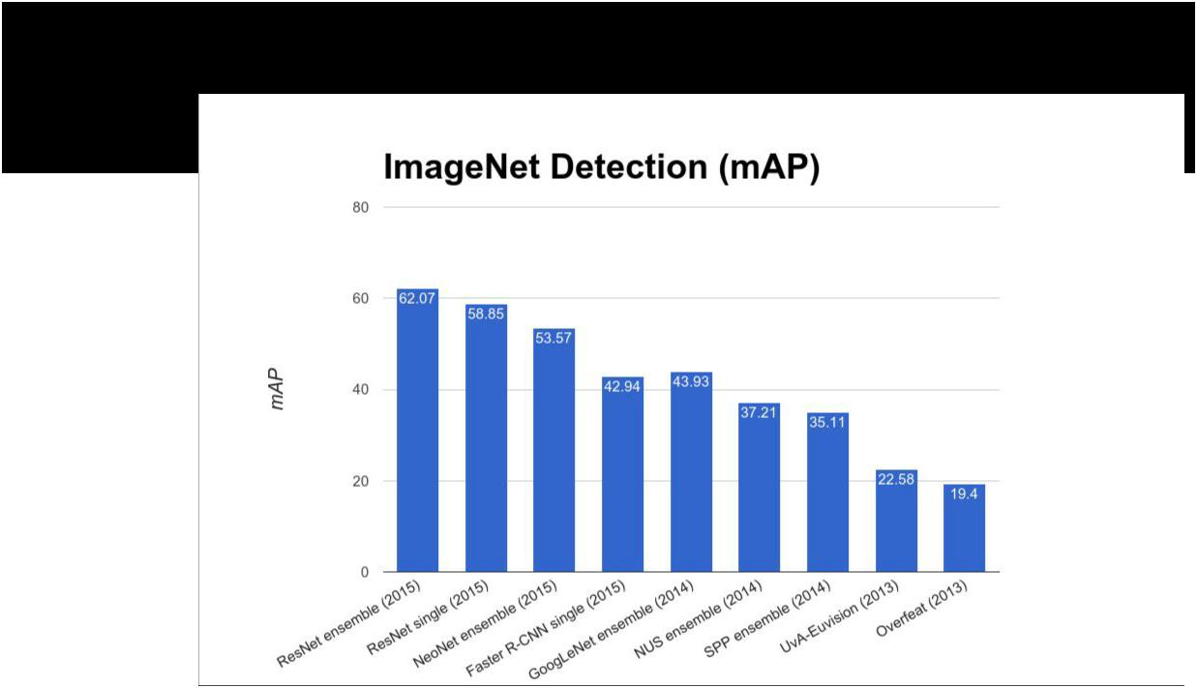ImageNet Detection 2013 - 2015



Fei-Fei Li & Andrej Karpathy & Justin Johnson Lecture 8 86 1 Feb 2016

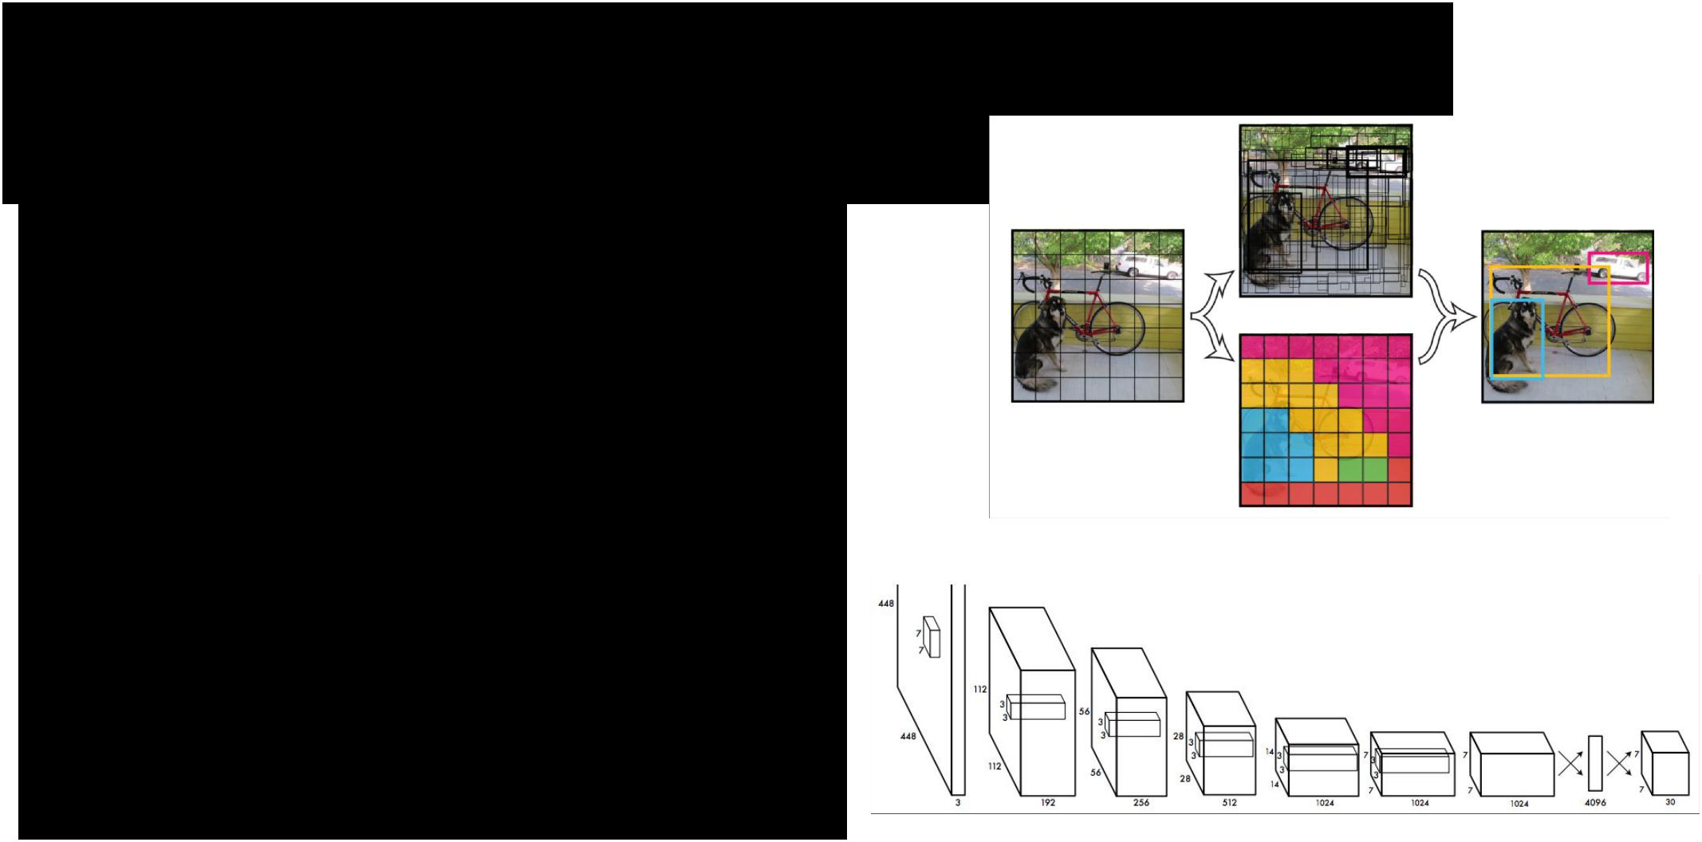YOLO: You Only Look Once Detection as Regression

Divide image into S x S grid

Within each grid cell predict:

B Boxes: 4 coordinates + confidence

Class scores: C numbers

Regression from image to 7 x 7 x (5 * B + C) tensor

Direct prediction using a CNN

Redmon et al, “You Only Look Once:

Unified, Real-Time Object Detection”, arXiv 2015



Fei-Fei Li & Andrej Karpathy & Justin Johnson Lecture 8 87 1 Feb 2016

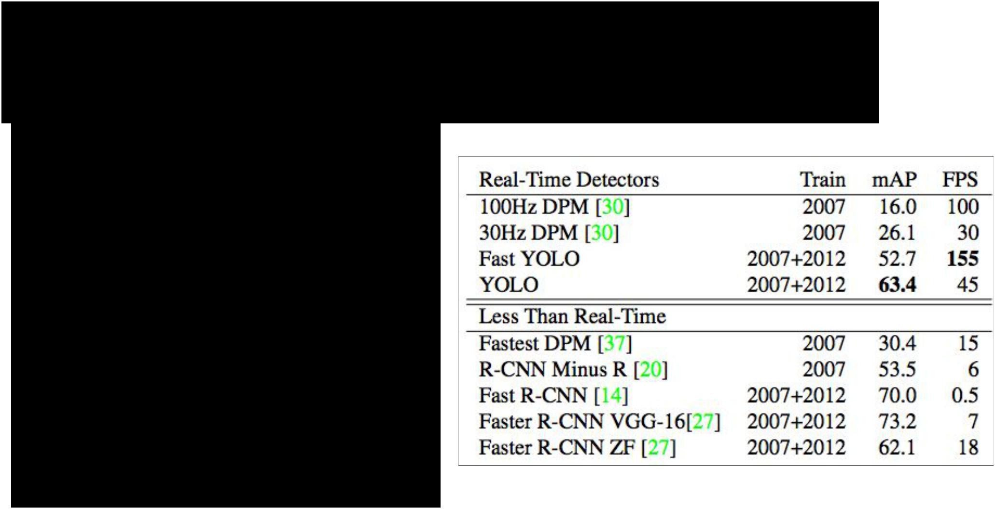YOLO: You Only Look Once Detection as Regression

Faster than Faster R-CNN, but not as good

Redmon et al, “You Only Look Once:

Unified, Real-Time Object Detection”, arXiv 2015



Fei-Fei Li & Andrej Karpathy & Justin Johnson Lecture 8 88 1 Feb 2016

Object Detection code links:

**R-CNN**

(Cafffe + MATLAB): <https://github.com/rbgirshick/rcnn> Probably don’t use this; too slow

**Fast R-CNN**

(Caffe + MATLAB): <https://github.com/rbgirshick/fast-rcnn>

**Faster R-CNN**

(Caffe + MATLAB): <https://github.com/ShaoqingRen/faster_rcnn>

(Caffe + Python): <https://github.com/rbgirshick/py-faster-rcnn>

**YOLO**

<http://pjreddie.com/darknet/yolo/>

Maybe try this for projects?



Fei-Fei Li & Andrej Karpathy & Justin Johnson Lecture 8 89 1 Feb 2016



Recap

**Localization**:

* Find a fixed number of objects (one or many)
* L2 regression from CNN features to box coordinates
* Much simpler than detection; consider it for your projects!
* Overfeat: Regression + efficient sliding window with FC -> conv conversion
* Deeper networks do better
* Find a variable number of objects by classifying image regions
* Before CNNs: dense multiscale sliding window (HoG, DPM)
* Avoid dense sliding window with region proposals
* R-CNN: Selective Search + CNN classification / regression
* Fast R-CNN: Swap order of convolutions and region extraction
* Faster R-CNN: Compute region proposals within the network
* Deeper networks do better



|  |  |  |
| --- | --- | --- |
| Fei-Fei Li & Andrej Karpathy & Justin Johnson | Lecture 8 90 | 1 Feb 2016 |
|  |  |  |